Sermon 11 13 22 - Philip, A Salmon Swimmer

Introduction
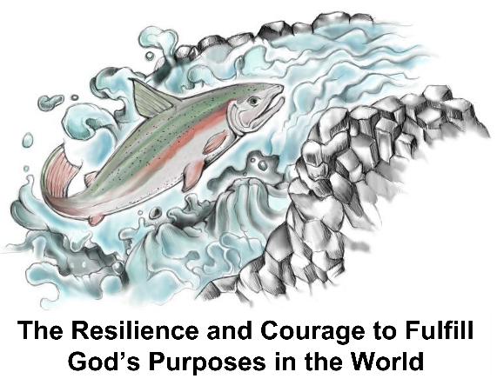
Philip, one of the 7 Greek-speaking men chosen for leadership in the early church, was a Salmon Swimmer. I coined that term in 2017 for a book (PP) I wrote describing the transformational discipleship needed for obedient Christians to fulfill God’s purpose for their lives. Salmon are the fish found in the waters mostly in North America and Europe, whose life journey is marked by their heroic effort to swim upstream as an adult in the river of their birth to spawn the next generation of salmon. They swim against the current, hurdling waterfalls, and overcoming every obstacle to reach their destination. Obedience to Christ in today’s world similarly requires Christians to “swim against currents of lukewarm, self-sufficient, consumer-based Christianity” (p.3) as non-conformist disciples who are not “decider Christians”.[those who] . . accept the truth of Christ’s death for his or her own life and decide to become a Christian. It is his ticket to heaven. But then live that life under his own priorities and only invites Jesus to bless those priorities (quoted from Richard Stearns’s book Unfinished, Thomas Nelson, 2013, p.58-60.) God has a different call for His people. Salmon naturally swim in schools which protect them in their fight against the predators and obstacles in their upstream journey.

Also, it is fascinating to realize that the salmon fish naturally are given a protective coating as they move downstream to the ocean where they grow and mature before they make the journey back upstream to their place of birth. That coating is like the human Salmon Swimmer Christian’s indwelling Holy Spirit (PP). It is through the Spirit that Christians choose and are empowered to no longer live for themselves but for Christ. As Christians, they realize that they are blessed to be a blessing (PP).
Continuing the fish analogy, the ocean for the Christian is the world with its temptations to live one’s life within its cultural and value-laden priorities. But, salmon have an inbred natural instinct that propels them to return to the river of their birth and leap even 11 foot waterfalls in an effort to fulfill that powerful instinct God built into them. It is the Holy Spirit who implants a similar urgency within the obedient Christian to live life in community on God’s kingdom priorities.

With this analogy as our context, we turn now to see how Philip was a Salmon Swimmer Christian Let us pray.
(PP blank)

Philip’s non-conformist life choices
After the martyrdom of Stephen, another of the 7 leaders from the early church, a great persecution arose in Jerusalem, forcing many followers of Jesus to flee into the surrounding countryside and neighboring area. Philip went to Samaria. That is the first nonconformist life-style choice we notice in Acts 8:5. Jesus had told the Apostles that after the Holy Spirit came, they were to be his witnesses in Jerusalem, Judea, Samaria and to the ends of the earth. But the Jews did not associate with Samaritans (Jn.4:9). There was centuries old political and religious rivalry (NIV Application commentary, Gary Burge, pp. 140,141). When the Assyrians conquered the northern kingdom in 722 BC, they repopulated it with people from throughout their empire. This resulted in paganism and many religious practices forbidden in the Torah. In addition the Samaritans rejected the writings of the Prophets and histories and wisdom literature, only accepting Genesis through Deuteronomy and choosing as their temple site on Mt. Gerizim, not Jerusalem where Solomon built his temple. (Burge, Idem). Samaritans were a hated people hated by the Jews and in their travels, the Jews week long distances out of their way to avoid going through it.

Not Philip. He resisted those cultural and religious behaviors and histories and went there to proclaim the good news about Jesus. And, not surprisingly when we are on God’s agenda, God blessed his ministry there. Acts 8:6-8 :” Crowds listened intently to Philip because they were eager to hear his message and see the miraculous signs he did. ⁷ Many evil^{[a]} spirits were cast out, screaming as they left their victims. And many who had been paralyzed or lame were healed. ⁸ So there was great joy in that city.” It was such an amazing response that the Jerusalem church sent Peter and John to confirm the good news. The Mother church in Jerusalem wanted to confirm and bless this budding new work. And they did. Philip actually became a model of obedience to Christ’s great Commission that they knew – in ways that extended beyond how they were witnessing for Christ in Jerusalem. Philip, representing the second generation of leaders in the church, was used by God to teach and motivate the first generation apostolic leadership to see beyond their ethnicity and Jewishness to the large world God cared for.

Yet, despite Philip’s flourishing ministry in Samaria, God had other plans. Right in the midst of this amazing fruitful ministry in Samaria, Philip is instructed to leave the area and “go south to the road – the desert road – that goes down from Jerusalem to Gaza.“

That simply didn’t make sense. Any self-sufficient Christians, relying on his own wisdom and experience would rightly reason – why leave a fruitful ministry where there are miracles showing God’s blessing and people are turning to the Lord? This is a time to settle in, disciple these new converts and keep building on the momentum of the great openness in Samaria to the gospel. Reasonable, rational thinking, right? The same kind of reasoning from the salmon analogy that would naturally keep salmon happily thriving in the ocean and not being driven by a God-implanted innate urge to leave for a greater goal beyond themselves.

But God prevailed because Philip had learned to recognize the leading of God and obeyed immediately. Remember he was chosen for his leadership role in Jerusalem because of his good reputation, his wisdom, and his being filled with the Spirit. And so follow the Spirit he did – from a thriving metropolis to a desert road in the middle of nowhere. A Salmon Swimmer response of obedience.
But there’s more. Philip was driven by God’s call on his life to be a spiritual reproducer (PP). He was motivated by God’s heart of evangelism.- he was what some call a “soul winner.” Dawson Troutman, the founder of the Navigators said, “Soul winners are not soul winners because of what they know but because of Whom they know and how well they know Him and how much they long for others to know him.”(Born to Reproduce, Billy Graham Organization, 1955, p. 45)

We know this because as Philip was traveling on the desert road, he met an Ethiopian who was sitting in his chariot reading the prophet Isaiah. Verse 29: The Spirit told Philip, “Go to that chariot and stay near it. Then Philip ran up to the chariot and heard the man reading Isaiah the prophet. “Do you understand what you are reading?” Philip asked. How can I, he said, unless someone explains it to me?” So he invited Philip to come up and sit with him. V. 35 and beginning with the passage from Isaiah 53 Philip told him the good news about Jesus.”
The Spirit prompted Philip to go to a man in a remote place, a man of great stature and influence from another country, and explain the good news of the gospel to him. It is widely believed that this man then became the ambassador for Christ as he returned, believing in Jesus, to his own country. This was God’s initial opening of the gospel to the continent of Africa.
And it happened because Philip was a Salmon Swimmer with the courage, the passion, and the obedient heart to go (PP) wherever God led him and lead people to Christ. Two of the qualifications he needed for his deacon role in Jerusalem were wisdom and a Spirit-filled life. We see both those qualifications lived out in his encounter with the Ethiopian: (PP) 1. He started the conversation with a question, addressing the Ethiopian’s need. 2. He knew the Scripture so he could interpret the passage the Ethiopian had asked about. 3. He could discern that God was already at work in the Ethiopian’s heart. 4. He kept the focus on Christ. 5. He looked for an action response. (A. Fernando, NIV Application Commentary, Acts, 1998, pp. 290-291)

His model is a great challenge and motivation for us today. Who are we needing to reach out to in our immediate community, the counties around us to the south, east and west, and the generations of unchurched folk who live in this area? And then who are we do disciple and equip to send to the other parts of the world as Christ’s ambassadors in word and deed? And, how are we fulfilling Christ’s command to go make disciples?
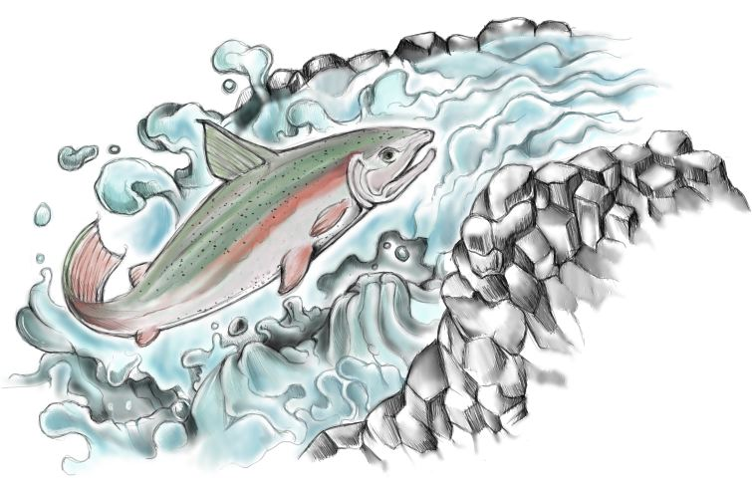
Our church will fulfill this call of God for us as more and more of us join His company as Salmon Swimmers! Come, let’s swim and grow together. We need each other’s strength and faith and spiritual gifts to make it possible! (PP) May we be a church of Salmon Swimmers!
Let us pray. Amen.

Dr. Mary Lou Codman-Wilson 11/13/22
Guest Preacher at Ogden Dunes Community Church in Ogden Dunes, Indiana

