New Hope Global sermon: Calling Lemonade Makers -Oct 13 2012

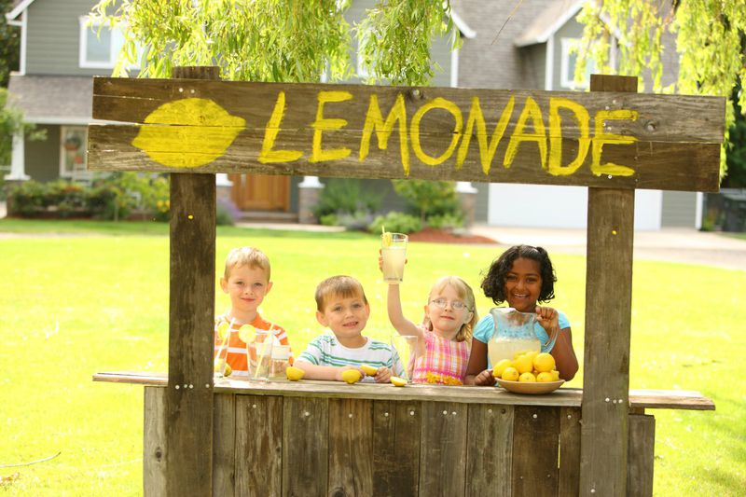

Introduction
In parts of the US where summer is a definite season (not a year-long climate condition), one can invariably see budding entrepreneurs with their lemonade stands. Lemonade is a cool, refreshing drink that can satisfy thirsty passerbys. So, many stop for the drink or to encourage the children who are hopefully holding out the drinks for purchase.

Lemonade is made by combining the sourness of squeezed lemons with the right amount of sugar, water and ice cubes. But making lemonade is a deliberate process that transforms bitter to sweet. Notice that the lemons have to be cut open and squeezed to get all their bitter juices out before one can add the sugar and water and make a refreshing drink. But then these entrepreneurs market it with balloons, and smiles and their enticing calls to passer-bys. They create a profit and a celebration from what would normally not be pleasurable. Who wants to just suck on lemons?

So making lemonade is a fitting analogy for seasons in our Christian life that seem bitter or sour to the soul. As the old saying goes: “When life gives you lemons, make lemonade!” The Apostle Peter uses the word “seasons” when he is talking about trials. Here is how I memorized I Peter 1: 6 decades ago in the King James Bible:

Blessed be the God and Father of our Lord Jesus Christ, which according to his abundant mercy hath begotten us again unto a lively hope by the resurrection of Jesus Christ from the dead, ⁴ To an inheritance incorruptible, and undefiled, and that fadeth not away, reserved in heaven for you, ⁵ who are kept by the power of God through faith unto salvation ready to be revealed in the last time. ⁶ Wherein ye greatly rejoice,
though now for a season, if need be, ye are in heaviness through manifold temptations:
⁷ that the trial of your faith, being much more precious than of gold that perisheth, though it be tried with fire, might be found unto praise and honour and glory at the appearing of Jesus Christ: whom having not seen, ye love; in whom, though now ye see him not, yet believing, ye rejoice with joy unspeakable and full of glory: ⁹ Receiving the end of your faith, even the salvation of your souls. (KJV)

A season of trials.

This is the reality millions are facing around the world in 2021 – in and out of the church. And it’s the current reality of many of us at New Hope Bible Fellowship. Being a Christian does not exempt us from the seasons of trials. But Peter explains that God uses these trials to strengthen and refine our faith so it brings honor to Jesus Christ at his appearing. He puts the trials in the context of the living hope God gives to all those who have experienced God’s new birth – a hope that has an inheritance in heaven, that is firmly established by Christ’s resurrection and that is part of believers’ being shielded by God’s power until Christ comes again. It’s a living hope, a sustaining hope, and though a present reality, a future hope that will be realized. And holding onto that hope does have power, indeed. But long-standing trials have a way of wearing one down spiritually and emotionally. They become a chronic problem, not just an acute problem – or at least that’s what it feels like as they persist week after week, month after month, sometimes year after year.

So, since trials are the reality of life and have a God-s designed purpose, I felt we needed to get a handle on how to cope with them better and transform them – in other words, how to make lemonade out of lemons! I think the long-standing fact of these trials for many of us means we need to marshall our forces together and become intentional lemonade makers together. Here’s how I envision this happening.

Becoming lemonade makers
Point One. Let’s start with a literal lemonade recipe and then find its counterpart in the spiritual realm. A McCalls Cookbook recipe calls for ¾ cup of sugar for every 3 lemons. The lemons are cut in half and squeezed until all the bitter juice is extracted. Then that juice is mixed with the sugar and 1 quart of water and ice cubes, and – voila – lemonade. (McCalls Cook Book, Random House, 1963, p, 97). What is noteworthy is that this is not just a dash of sugar. It is the recognition that the severity of tartness calls for a substantial amount of sweetness to transform it. Basically, this means ¼ cup of sugar for every lemon.

Can you see the application of this principle in life? Notice the amount of sugar needed to convert lemons to lemonade. And spiritually, that is our first principle as lemonade makers: we look for God-sightings around us, we look for the goodness and love of God – the sweetness we need - to counterbalance the sourness of lemons in our situation. And just like a fourth of cup of sugar sitting beside a lemon will not make lemonade, we have to mix them together. We have to look for the sweetness around us – in friends’ kindnesses and prayers and Scripture the Spirt brings and miracles that take place in our very context and then apply those in our mind and emotions to the lemons we face. We have to stir them together.

This is an issue of choice and discipline, beloved. When we are in a “season” of trials and suffering, it is easy to have them take center-stage. But being triumphant in that context requires that we focus equally on the goodness of God right then. As the Psalmist says in Ps. 94:19 “When anxieties (lemons) were great within me, Thy consolations cheer my soul”. The Psalmist had to consciously think of God’s consolations to counter the effect of the crowding anxieties attacking his mind. We have to choose to recognize the tangible evidences of God’s presence and love, and stir those into the bitter reality of the lemons we face each day. (I will give a practical example of this as we get to point two as lemonade makers.)

Lemons can last a long time and in life many of our lemony problems are long term. They are chronic issues, not acute issues which flare up for a moment and can be dealt with and resolved. And long-term suffering will wear down the soul. This is not God’s intent, but is a reality of how Satan will use our suffering to take us down into depressions, doubt and distress – the crabgrasses that hinder our lawn of faith which I described in last week’s sermon. The Bible talks about Satan’s role to wear down the saints in Daniel chapter 7: 23-27
²³ Then he said to me, “This fourth beast is the fourth world power that will rule the earth. It will be different from all the others. It will devour the whole world, trampling and crushing everything in its path. ²⁴ Its ten horns are ten kings who will rule that empire. Then another king will arise, different from the other ten, who will subdue three of them. ²⁵ He will defy the Most High and oppress the holy people of the Most High. He will try to change their sacred festivals and laws, and they will be placed under his control for a time, times, and half a time. ²⁶ “But then the court will pass judgment, and all his power will be taken away and completely destroyed. ²⁷ Then the sovereignty, power, and greatness of all the kingdoms under heaven will be given to the holy people of the Most High. His kingdom will last forever, and all rulers will serve and obey him.”

The word “oppress” in v. 25 means to wear down and try to wear out. The inner weariness and mantle of darkness and exhaustion and hopelessness that comes upon Christians is not from God; it is a tactic of the enemy. And we are most prone to these attacks when our lemony problems and relationships are long-term. Because they are often chronic, (i.e., continuing long-term), not acute (for a brief span), a simple Bible verse one day will not usually lift them. What we need is the reinforcement of other verses and other stories and God-sightings that others share with us. And that brings us to Point Two for lemonade makers.

Point Two: What I suggest is that we create a Lemonade Makers Club! A volitional group we can subscribe to and thus join with others who are facing the long-term problems of their unresolved issues and who need the support and encouragement of others who are living with lemons. I know every time I hear of God’s work and answers to prayer and God-sightings in the lives of those who are facing tough situations, it strengthens my faith and keeps me remembering the “consolations of God which cheer my soul.” I believe we can do this best and most consistently through community.

So, for those who subscribe to this email club, we would send out a weekly bulletin like the one below and include a story or two of the week from members who had God-sightings, plus have a column of answers to prayer and another of prayer requests. That way we can continue to shield one another from the wearing down of our lives through our chronic problems. It is true that misery loves company, but this is a level above that mutual empathy – it is a chance to help us move into more godly responses and come through with a faith that WILL bring honor and glory and praise to Christ when He returns. Here’s what this bulletin could look like. I submit my story of God’s kindness to me from Thurs. through Sat. of this past week.
Lemonade Makers Bulletin 10/13/21

God-sightings: Dr. Mary Lou

My chronic lemons are related to the progression of Keith’s Alzheimers with still no caregiver to help me carry the load. This past week I had Bing and then Miyuki and Dionisio who each took Keith and I shopping on different days. That in itself is huge but the consolations were particularly striking on Thursday and Saturday.
On Thursday Carl, who comes to visit Keith one a week, offered to come again but it was too cold to sit outside. With the rules of the household, he knew h could not come in for a visit.(another chronic lemony problem). I suggested he take Keith out for a drive, and he decided to take Keith to a bakery about 25 minutes away by the Fox River.! All you who know Keith’s sweet tooth will laugh in delight at that idea! Carl took Keith to the bakery and then they walked together on a trail beside the river. They were gone for 2 hours – the first real break I had had in many weeks.
Then Saturday not one but two different neighborhood men worked together and painted my bedroom/office a lovely peach cloud color. It was a depressing dark split pea green. The landlord had approved of the change when I asked and these neighbors made it possible. I now sit in a bright, comforting color that makes the room appear much larger and more inviting: it feels like the breath of dawn each day.
That afternoon, while they were painting, Kun came and took Keith and I out to a second-hand furniture store so we could buy a small dining room take that fits into our 15x12 foot living room/dining room space. Jubilee Furniture is a large warehouse-looking store where people donate furniture and the proceeds go to support a local mission. We spent over one half an hour looking at every possible table that we could use. To no avail. Just as we were about to leave, Kun spotted a solid wooden hexagonal table that looked like it could work. It was 29” diagonal. But it was too expensive for me to buy, since I don’t currently have any salary to cover such expenses. I liked the table and thought it would fit the ethos and space of our living room, but said, “let’s go – we will keep looking; I cannot afford this one. “ And Kun said, “I will pay for it for you.” And he did! In two days what I consider as extraordinary acts of kindness and generosity by four different men have been God’s consolations which I have mixed with my lemons and used to make lemonade. Hallelujah!

Prayer requests Praises

If you choose to be a Lemonade Maker, would you be willing to share a story of God-sightings you have had in the past week? Subscription will be $10. 00 a month to help pay my secretarial costs to collate and send out this bulletin weekly. If this is a club you want to join, you can pay by zelle at Chase Bank, or paypal and we will set it up when you submit. Let’s see what the response is.

My hope is that a number of us who are facing lemon situations currently can band together and become God’s Lemonade Makers during our season of trials. I find it is easier to be a Lemonade Maker when we do it together, rather than just working it out alone. I also believe many of us could have our own faith strengthened by the encouragement and support of one another in this specific way. Amen.
In His Name and for His glory.
Dr. Mary Lou Codman-Wilson, Pastor
New Hope Global Fellowship 10 13 21

