Sermon Prayer Changes Things 9 11 2022

Introduction
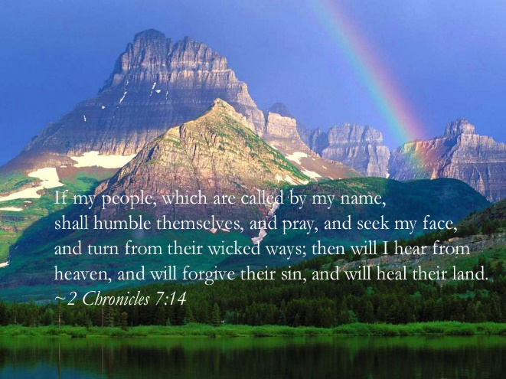
I found it interesting as I began this sermon to write out the title and the date together = 9/11 Prayer Changes Things. 9/11 has been indelibly inscribed on our national consciousness as a day of horror and a victory for incredible evil. It is a day that brought our country to its knees. I wonder if we have learned since then that being on our knees is the safest place to be every day!
Remember God’s promise in 2 Chronicles 7:14?
“If my people, who are called by my name, will
humble themselves, will humble themselves and pray
and seek my face and turn from their wicked ways,
then will I hear from heaven and will forgive their sin
and will heal their land. “
That was a promise we claimed as a nation then and a promise every nation on earth still needs to claim today! Why? Because, as Alfred Lord Tennyson said, “More things are wrought by prayer than this world dreams of.”

I started the sermon with the terrorist bombing of the Twin Towers in New York city on Sept 11 2001. So my first prayer story today is on how prayer defeated another person with a terrorist intent. This is the true story of Stephen Lungu who is now the International Evangelist for African Enterprise, a large Christian organization based in several continents. He tells his life story in Out of the Black Shadows.
The Black Shadows was the name of the gang that he was part of in Kenya, East Africa. When Stephen was
young, he was abandoned and grew up on the streets of Harare Kenya , where he had to fend for himself
by eating out of garbage cans. He joined a street gang that robbed people to survive and acted lawlessly.
One day he and his gang went to a revival tent meeting with the intent to bomb it. But while he was
there, with grenade in hand, he heard the gospel being preached and he gave his life to the Lord. He
left that tent a changed young man and began preaching what he knew of the gospel on busses, trains and
wherever he went. [He is now the International Evangelist for African Enterprise.] He has spoken to thousands of people across the globe about the Gospel of the Kingdom. . .
[But here’s how that dramatic change happened.] In his ministry he met up with a few old ladies who told him that they had been praying on the night of the revival tent meeting for a gang member to be saved – and he was. He was the answer to their prayers. . .Through these elderly ladies praying at home for someone to be saved, God took an abandoned baby who had few prospects in life and used him for the Kingdom in mighty ways. These ladies prayed on one continent and changed life on another.” (MLCodman, Salmon Swimmers, Westbow Press, 2017, pp.63-64) Prayer changes things and people!! Let us pray!
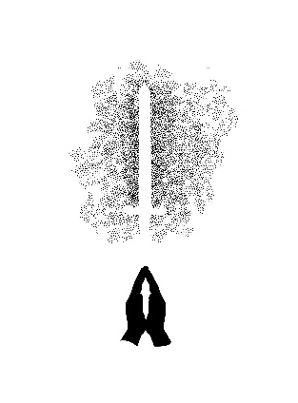
The Power of Prayer
Prayer is our oxygen, beloved, necessary for our on-going walk with God. It is not just some supplementary rocket to get our projects or church off the ground. It is the work. This graphic is from the chapter entitled “Prayer Warriors” in my book Salmon Swimmers, published in 2017 by Westbow Press. The graphic was actually created by my oldest granddaughter on our daughter’s side. Claire is a professional graphic artist, as is our oldest grandson from Bruce. Sam Wilson designed many of the other graphic in that book. Notice each part of this graphic. The powerful symbol of prayer in the praying hands, the illumined Sword, symbolizing our use of the Sword of the Spirit (the Bible) when we pray, and the darkness that prayer and the Sword are penetrating. Prayer changes things!

Paul tells the Thessalonians: “Pray without ceasing.” And he tells the Colossians: “Devote yourselves to prayer, being watchful and thankful. “Prayer changes Things” is our theme today so we can be the kind of Christians who change the world through prayer, led by the Holy Spirit.
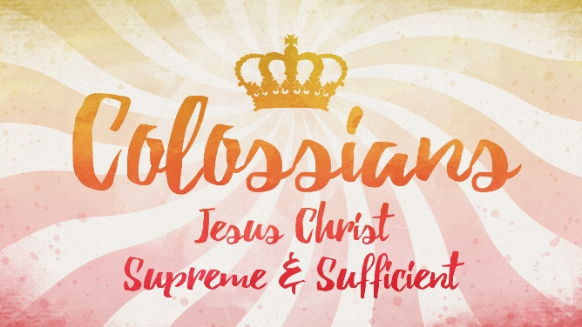
How is it possible?

The whole premise of this command and of all the aspects of the Christian life we have described in the book of Colossians is the Lord Jesus Christ.

He is the Supreme Lord of heaven and earth, the One at whose name very knee shall bow (Phil.2:10-11); the One who holds all things together by the Word of His power (Col.1:7). The One whose grace is sufficient (2 Cor. 12:9), and for whom nothing is impossible. Our Lord and Savior Jesus Christ is the One who teaches us how to pray (Mt.6:5-13), and who now in heaven is continually interceding for us (Heb. 7:25). Praying without ceasing is not only possible but necessary to counter all the evil in the world and usher in God’s Kingdom of love and hope and power. Yet it is always done within the context of “the Spirit of Christ Himself praying with and for us” (J.D. Peacock, Perfectly Suited, Aspire Press, 2022, p 157). This is the confidence and help we need to be devoted to prayer.

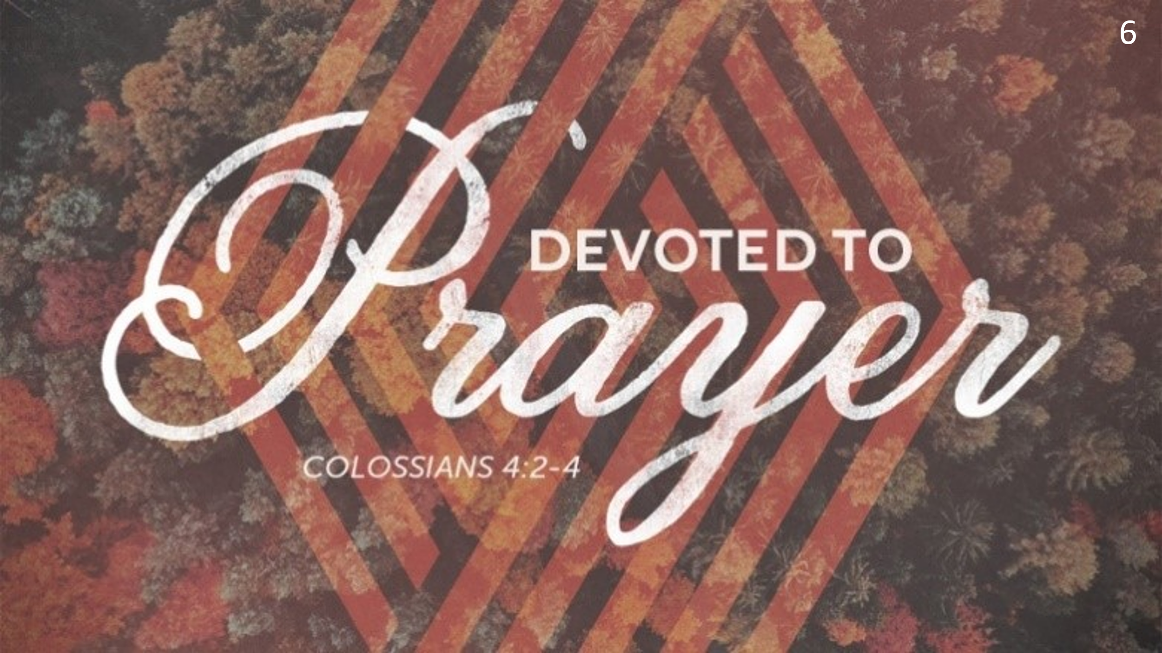
But what does “devoted to prayer” mean practically? Being devoted involves a serious commitment, beloved. In prayer it is not just grace at meals or an occasional “bless you, Jane,” or the prayers we only raise at church in answer to people’s prayer requests. For the Christian “devoted” means dedicating one’s priorities and energy to some purpose or task that is paramount in one’s calling from God. Devoted to prayer means I have made prayer a priority that requires my best energy, time, alertness and thanksgiving every day, every month, every year of my life.

Through the power of the Holy Spirit this kind of prayer changes things because it is based on God’s character; it is mighty and effective; it is strategic, and it is fueled by faith. Let’s consider each of these 4 markers of the prayers God answers.

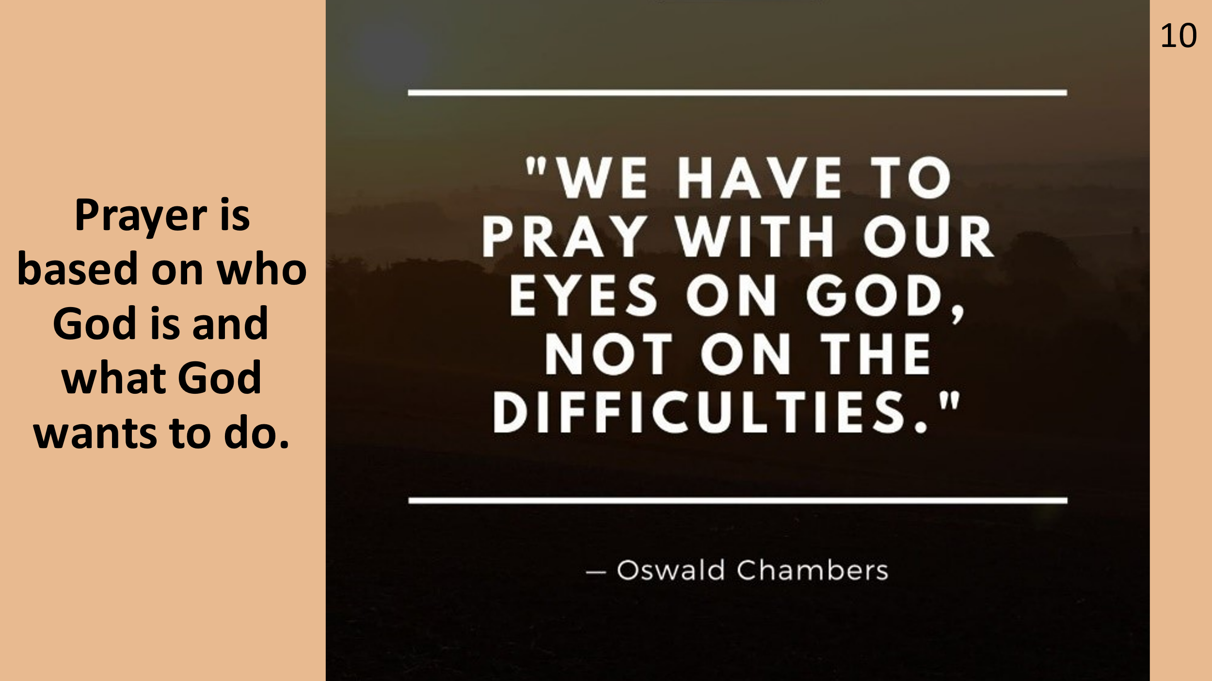
First, prayer that changes things is based on God’s character and promises. You remember the story of Peter in prison from Acts 12? King Herod Agrippa^{[a]} had already killed the apostle James (John’s brother) with a sword, and Peter was next. Verse 5: “ But while Peter was in prison, the church prayed very earnestly for him.” Here is how God answered those earnest prayers:
⁶ The night before Peter was to be placed on trial, he was asleep, fastened with two chains between two soldiers. Others stood guard at the prison gate. ⁷ Suddenly, there was a bright light in the cell, and an angel of the Lord stood before Peter. The angel struck him on the side to awaken him and said, “Quick! Get up!” And the chains fell off his wrists. ⁸ Then the angel told him, “Get dressed and put on your sandals.” And he did. “Now put on your coat and follow me,” the angel ordered.
⁹ So Peter left the cell, following the angel. But all the time he thought it was a vision. He didn’t realize it was actually happening. ¹⁰ They passed the first and second guard posts and came to the iron gate leading to the city, and this opened for them all by itself. So they passed through and started walking down the street, and then the angel suddenly left him.
¹¹ Peter finally came to his senses. “It’s really true!” he said. “The Lord has sent his angel and saved me from Herod and from what the Jewish leaders^{[c]} had planned to do to me!”
¹² When he realized this, he went to the home of Mary, the mother of John Mark, where many were gathered for prayer. ¹³ He knocked at the door in the gate, and a servant girl named Rhoda came to open it. ¹⁴ When she recognized Peter’s voice, she was so overjoyed that, instead of opening the door, she ran back inside and told everyone, “Peter is standing at the door!”
¹⁵ “You’re out of your mind!” they said. When she insisted, they decided, “It must be his angel.”
¹⁶ Meanwhile, Peter continued knocking. When they finally opened the door and saw him, they were amazed. ¹⁷ He motioned for them to quiet down and told them how the Lord had led him out of prison. “Tell James and the other brothers what happened,” he said. And then he went to another place.”
How wonderfully kind God is – The Lord sent an angel who brought Peter miraculously out of prison even when the church didn’t believe it was actually Peter who knocked on John Mark’s mother’s door where the church was praying!
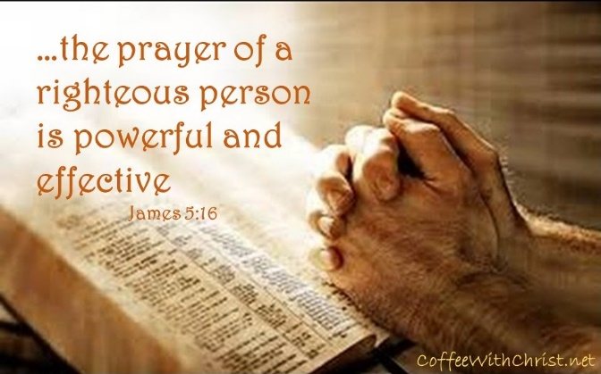
The apostle James knew what he was talking about when he wrote in his letter: “The prayer of a righteous person is powerful and effective” (Jam 5:16) This is the kind of prayer that changes things!

Peter’s rescue from prison was a powerful miracle that greatly encouraged the church and enraged the church’s enemies!
In Peter Wagner’s book Prayer Shield, he describes a prayer warrior:

You may see her in the grocery with her children
Or in the city nine to five each working day.
She’s a mother or a teacher or a woman all alone
But she’s something else entirely when she prays.
We don’t see her lonely nights of intercession
Or the tears she sheds with every whispered prayer.
We may not see the secret things hidden in her heart
But the eyes of God are watching her with care.
She’s a prayer warrior down on her knees
Wrestling with powers and principalities
Standing in the gap for others
For her sisters and her brothers
Reaching heaven with her heart,
(C. Peter Wagner, Prayer Shield, How to Intercede for Pastors and Christian Leaders, Chosen books, 2014, p. 49).

This also makes prayer very strategic. Satan was behind Herod’s persecution of the church. But prayer reversed that evil goal. Yet, when we fail to fulfill our God-chosen devotion to prayer, Satan can fulfill his goal to “steal, kill and destroy God’s people:

A young couple was bidding farewell to their home country church as they were about to leave for an African field, known as The White Man’s Grave. The husband said, ‘My wife and I have a strange dread in going. We feel much as if we were going down into a pit. We are willing to take the risk and go if you, our home circle, will promise to hold the ropes.’ One and all promised.

Yet, less than two years later, both the wife and the little one God had given them succumbed to the dreaded fever. Soon the husband realized his days too were numbered. Not waiting to send word home of his coming, he started back at once and arrived at the hour of the Wednesday prayer-meeting. He slipped in unnoticed, taking a back seat. At the close of the meeting he went forward. An awe came over the people, for death was written on his face. He said:
‘I am your missionary. My wife and child are buried in Africa and I have come home to die. This evening I listened anxiously, as you prayed, for some mention of your missionary to see if you were keeping your promise, but in vain! You prayed for everything connected with yourselves and your home church, but you forgot your missionary. I see now why I am a failure as a missionary. It is because you have failed to hold the ropes!’” (Rosalind Goforth, Goforth of China, Kessinger Publishing LLC, 2010, pp. 65-66).

And finally, prayer with faith . I like these two quotes: “Prayer is the arena where our faith meets God’s abilities.” And Faith does not make things easy; it makes them possible!!
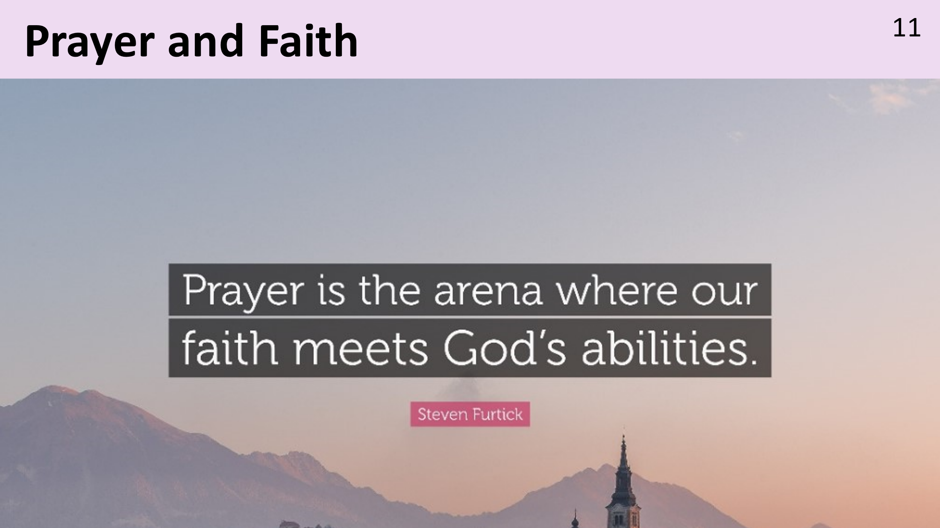
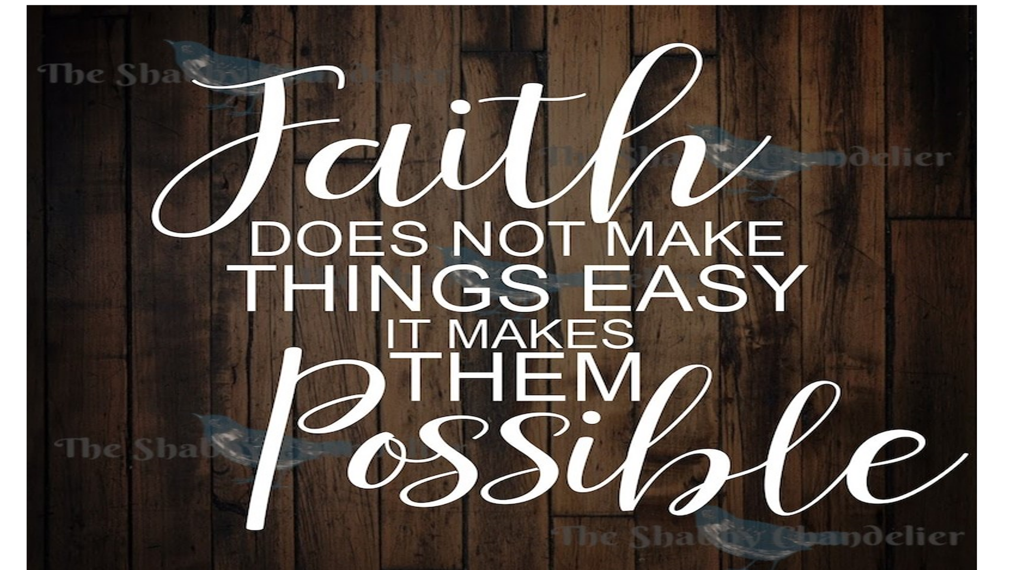
With those two truths ringing in our ears, I close with the story of the story of a little boy’s faith that fulfilled the prayers of Christians in a large secular hospital:
In the fall of 2005 a little 9-year-old boy named Austin had to have his tonsils removed. “Before the surgery, an anesthesiologist came in to start an IV. He was wearing a cool surgical cap covered in colorful frogs. Austin loved that "frog hat." When the doctor started to leave, Austin called out, "Hey, wait." The doctor turned. "Yeah, buddy, what do you need?”
“Do you go to church?" "No," the doctor admitted, "I know I probably should, but I don’t.”
Austin then asked, "Well, are you saved?” Chuckling nervously, the doctor said: "Nope. But after talking to you, maybe it's something I should consider."
Pleased with his response, Austin answered, "Well, you should, 'cause Jesus is great!" "I'm sure he is, little guy," the doctor said, and quickly made his exit.
When Austin's surgery was finished, the anesthesiologist came into the waiting room to talk to Austin’s mother. He told her the surgery went well, then said, "Mrs. Blessit, I don't usually come down and talk to the parents after a surgery, but I just had to tell you what your son did."
“Oh boy,” thought the mom. “What did that little rascal do now?”
The doctor explained that he'd just put the mask on Austin when her son signaled that he needed to say something. When the doctor removed the mask, Austin blurted, "Wait a minute, we have to pray!"
The doctor told him to go ahead, and Austin prayed: "Dear Lord, please let all the doctors and nurses have a good day. And Jesus, please let the doctor with the frog hat get saved and start going to church. Amen."
The doctor admitted that this had touched him. "I was so sure he would pray that his surgery went well," he explained. "He didn't even mention his surgery. He prayed for me! Mrs. Blessit, I had to come down and let you know what a great little guy you have."
A few minutes later, a nurse came to take the mother to post-op. She had a big smile on her face as they walked to the elevator.
"There's something you should know," she said. "Some of the other nurses and I have been witnessing to and praying for that doctor for a long time. After your son's surgery, he tracked a few of us down to tell us about Austin's prayer. He said, 'Well, girls, you got me. If that little boy could pray for me when he was about to have surgery, then I think maybe I need his Jesus, too.'"

My challenge to you all practically is this:
“Is prayer your steering wheel or your spare tire?”
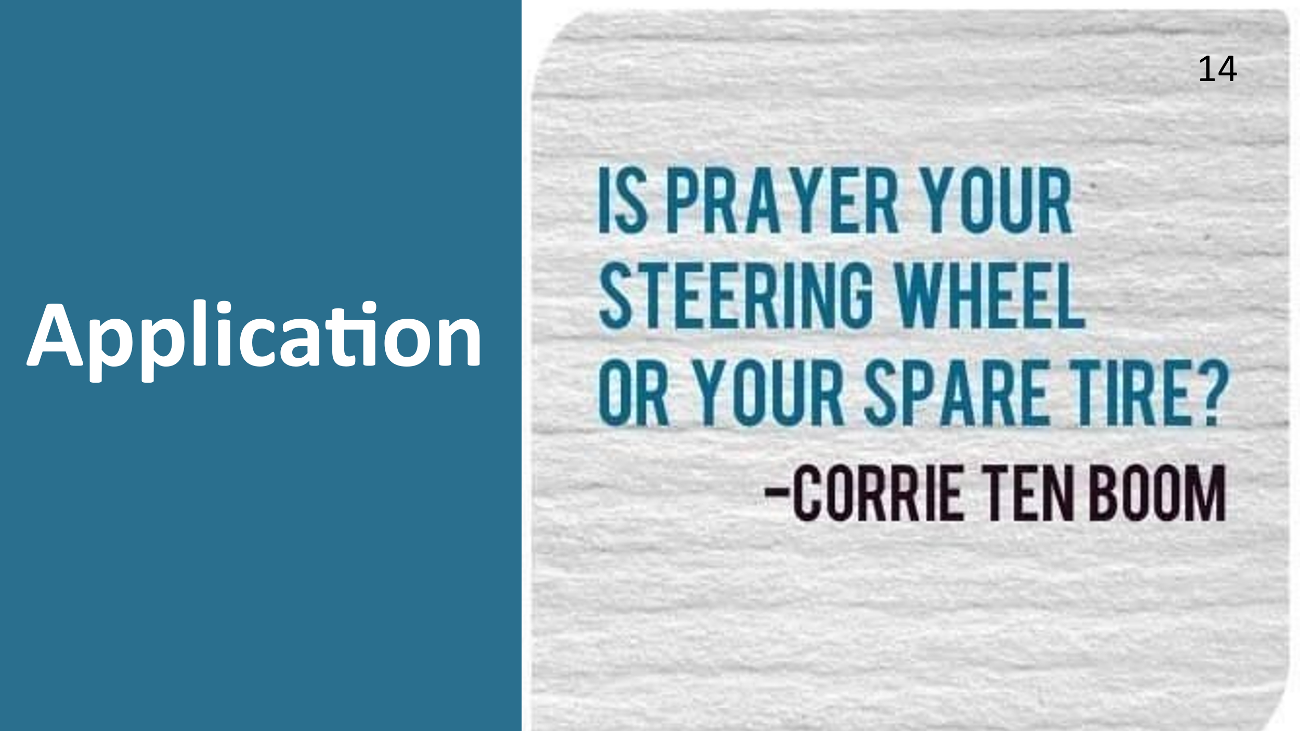
Let us pray.

Dr. Mary Lou Codman-Wilson
Guest Preacher at Ogden Dunes Community Church
9/11/22
Sermon posted on her website maryloucodmanwilson.com.

