New Hope Global Sermon Aug 25 - Surround Sound
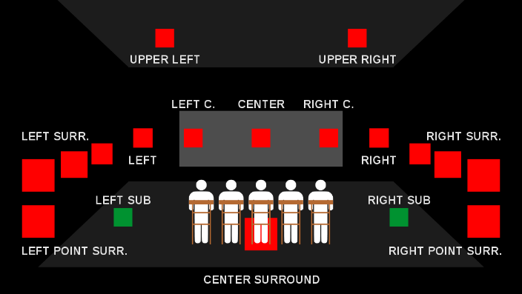
Introduction
Many of our older citizens were introduced to surround sound in the movie theatres through Walt Disney movies in the 1950-60’s. But that technology was extremely expensive and not accessible to the average person. True surround sound technology was only introduced to the home environment in 1982 with Dolby Surround technology. One ad for a 360’ speaker says it is “engineered to spread deep., jaw-dropping sound in every direction. . .immersing you in that same feeling you felt at your favorite concert.” What people experience in the movie theatres and concert SURROUND SOUND TECHNOLOGY
venues is now available in private settings, and it is awesome indeed!

God’s Surround Sound
To surround means to encircle, encompass. It can be negative, as when Elisha’s enemies surrounded Dothan to capture him (2 Kings 6:15). But it is also positive, referring to God’s surrounding of His people. Elisha knew that. So, in the Dothan situation when the servant panicked at the sight of the surrounding army, “Elisha told him ‘those who are with us are more than those who are with them.’ And Elisha prayed: ‘O Lord, open his eyes so he may see.’ Then the Lord opened the servant’s eyes and he looked and saw the hills full of horses and chariots of fire all around Elisha” (2 Ki.6:16-17).

It’s this sight of faith that I want to bring before us as God’s reality today.

Three psalms highlight this truth:
- Psalm 125:2: “As the mountains surround Jerusalem, so the Lord surrounds his people.” NIV
- Psalm 5:11-12 “But let all who take refuge in you be glad; let them ever sing for joy.
Spread your protection over them, that those who love your name may rejoice in you.¹² Surely, Lord, you bless the righteous; you surround them with your favor as with a shield.” NIV
- Ps. 32:7, 10 “You are my hiding place; you will protect me from trouble and surround me with songs of deliverance. ⁸ I will instruct you and teach you in the way you should go; I will counsel you with my loving eye on you. ⁹ Do not be like the horse or the mule, which have no understanding but must be controlled by bit and bridle or they will not come to you. ¹⁰ Many are the woes of the wicked, but the Lord’s unfailing love surrounds the one who trusts in him.” NIV
- And, Ps. 3:2-6 “You, Yahweh, have become my Shield; You take me and surround me with yourself.^{[b]}Your glory^{[c]} covers me continually. You lift high my head.^{[d] 4} I have cried out to you,^{[e]} Yahweh, from your holy presence.^{[f]}You send me a Father’s help. ⁵ So now I’ll lie down and sleep like a baby—then I’ll awake in safety, for you surround me with your glory.⁶ Even
- though ten thousand dark powers^{[g]} prowl around me, I won’t be afraid.” (Passion)
In these verses the Passion translation usually substitutes “surround” with “wrap around”, i.e.,
- Ps. 5:12 “Lord, how wonderfully You bless the righteous. Your favor wraps around each one and covers them under Your canopy of kindness and joy.”
This surrounding work of God speaks of the protection, the security and the blessing of being surrounded by the Lord. We can sleep in peace and awake in safety. We can lift high our head. We can rest in the protection of the Lord.
But’s there’s another aspect of this surround sound that particularly struck me this week. The Lord “surrounds us with songs of deliverance.” Have you thought much about that, beloved? With songs of deliverance. We are surrounded by God’s songs of deliverance. Do you hear them? Do you believe it? It’s a wonderful image of victory.
In fact, there is an old hymn called “You are my hiding place” that celebrates this truth.
You are my hiding place. You always fill my soul with songs of deliverance whenever
I am afraid. I will trust in You. I will trust in You.
Let the weak say I am strong in the strength of my God. repeat 2x- (words and music: M. Ledner)
It’s this reality that is behind the book by Corrie ten Boon called The Hiding Place. Shortform has this concise summary:
The Hiding Place is an autobiographical memoir by Corrie ten Boom, a devoutly religious woman who lived in the Holland city of Haarlem during the Nazi occupation. Compelled by her unshakeable Christian morality, she defied tyranny to rescue her Jewish neighbors who faced annihilation during the Holocaust. She was ultimately caught and sent to the notorious Ravensbruck death camp, where she witnessed scenes of unimaginable cruelty. In the camp, it was Corrie’s bedrock faith in the glory of God that sustained her. She discovered that love was a far more powerful force than hate—for God’s love was truly unconquerable.

God’s songs of deliverance were what enabled Corrie and her sister to smuggle a Bible into their flea-infested barracks and hold Bible studies without the guards’ knowledge at Ravensbruck. They were what enabled her to endure the “unimaginable cruelties” in the camp and upon rescue ultimately to forgive the guards who tormented and persecuted all the women in the camp. Then, upon her recovery after her release she fulfilled Betsie’s request that she write the story The Hiding Place. The title has a double meaning. It not only relates to the hiding place in her family home where she sheltered Jews fleeing Nazi extermination, but also the horrors of the Nazi death camp Ravensbruck. Her book was published in 1974.

Songs of Deliverance
Eve when God is your hiding place, how can being surrounded by God’s songs of deliverance affect yours and my life in the coming days? This is the application question we need to answer.

I believe it can do as the scriptures say: it can lead us to lie down in peace and sleep, no matter how many issues and evils surround us. It can raise our focus from the surrounding problems to the reality of God’s victories at the cross where Christ nailed every principality and power to the cross and rose triumphing over them all (Col.2:14-15). It can help us remember that we are also surrounded by a great crowd of witnesses (Heb. 12:1) who have experienced God’s covering, steadfast love and deliverance in their own lives. It can give us persevering faith and our own songs of praise.

St. Patrick was a bishop and the patron saint of Ireland, credited with bringing Christianity to the Picts and Anglo Saxons. He was always in danger of martyrdom but a Gaelic hymn was written about the words engraved on his breastplate. He visualized God’s surrounding presence in terms of Christ:
Christ beside me, Christ before me, Christ behind me, king of my heart; Christ within me, Christ below me, Christ above me – never to part. Christ on my right hand, Christ on my left hand, Christ all around me – shield in the strife; Christ in my sleeping, Christ in my sitting, Christ in my rising – light of my life.

That’s living surrounded by God’s songs of deliverance. It’s a model for all Christians to follow. God will bless us, indeed, as we live in these realities. Amen.
Dr. M.L. Codman-Wilson,
Pastor New Hope Global Fellowship
8/25/21

