New Hope Global Sermon: Why would Jesus ask adult disciples to be childlike?

Introduction

All three synoptic gospel record Jesus’ blessing of the children. It’s culturally understandable that when the mothers initially brought their children to Jesus, the disciples shooed them away, thinking children were not worthy of the Master’s time. But Jesus thought otherwise:
¹³ Then they brought little children to Jesus so that he would lay his hands on them, bless them, and pray for them.^{[a]} But the disciples scolded those who brought the children, saying, “Don’t bother him with this now!”
¹⁴ Jesus overheard them and said, “I want little children to come to me, so never interfere with them when they want to come, for heaven’s kingdom realm is composed of beloved ones^{[b]} like these! Listen to this truth: No one will enter the kingdom realm of heaven unless he becomes like one of these!”^{[c]} ¹⁵ Then he laid his hands on each of them and went on his way. (Passion)

Earlier in Matthew’s gospel Jesus even featured children to answer the disciples’ question, ‘Who is greatest in the kingdom of heaven?’ His answer certainly was not what they had expected:
² Jesus called a little one^{[a]} to his side and said to them, ³ “Learn this well: Unless you dramatically change your way of thinking and become teachable like a little child^{[b]}, you will never be able to enter in. ⁴ Whoever continually humbles himself^{[c]} to become like this little child is the greatest one in heaven’s kingdom realm. ⁵ And if you tenderly care for this little one^{[d]} on my behalf, you are tenderly caring for me. ⁶ But if anyone abuses^{[e]} one of these little ones who believes in me, it would be better for him to have a heavy boulder tied around his neck and be hurled into the deepest sea than to face the punishment he deserves!^{[f]} (Passion)

For Jesus to use children as His model for adult disciples is extraordinary in itself. Children were not given such status in the hierarchal cultures of the day. So why would Jesus pick children for adults to exemplify?

The answers tell us a great deal about Christian character and God’s starkly counter-cultural values. That is the theme of the sermon this week.

Some semantics

First, it is important to clarify the distinction between being childish and child-like. Being childish is a derogatory term when applied to adult behavior. It describes petulant, ego-centric, immature and foolish behavior (Webster’s New Collegiate Dictionary. 4th Edition, 2008). Psychologists Cloud and Townsend also describe this immature behavior in adults who have not matured in character in adulthood. They call it ‘The child position:’
“If adults are not emotionally grown up to be equals – siblings – with other adults, they will experience peers as parental figures. They will feel “one-down” to others and therefore subject to people’s approval or judgment…People stuck in this position must see guilt as a sign that they have given other people the position of God-the-parent in their lives. They must move out of the position of being a child under parental approval and be adopted by God and answerable to Him (How People Grow, Dr. Henry Cloud, Dr. John Townsend, Zondervan, 2001, p. 181).
These descriptions of childishness are the antithesis of all the values Jesus advocated. In fact, when he says his followers should receive the kingdom of God as a child, he is talking about the childhood characteristics of humility, trust, teachableness, dependence, emotional vulnerability, creativity, imagination and playfulness. Often in adulthood we morph into the culture’s version of maturity and lose many of these God-honoring characteristics. Playfulness is a simple example.

In decorating our living space in Orlando, I have created “stations” around the room that represent various facets of our lives. I have travel posters from two Asian cities where I taught – Bangkok and Singapore, pictures of New England Inns because that is my background, pictures from Sam’s beach north of Boston that captures the privilege of wealth in my family, a picture of our church family and my PhD graduation certificate from Chicago, and pictures and mementoes from our year in Vienna when our children were just 2 and 4. I only have slides from that year in Vienna in 1967 but I knew we had a slide of both our children in Austrian dress from that year. I thought it would be a sweet part of our Vienna “station.” My grandson found the slide and had it converted to a photo. I include it here because of how Bruce presented himself for this picture. Playfulness, right?!!!
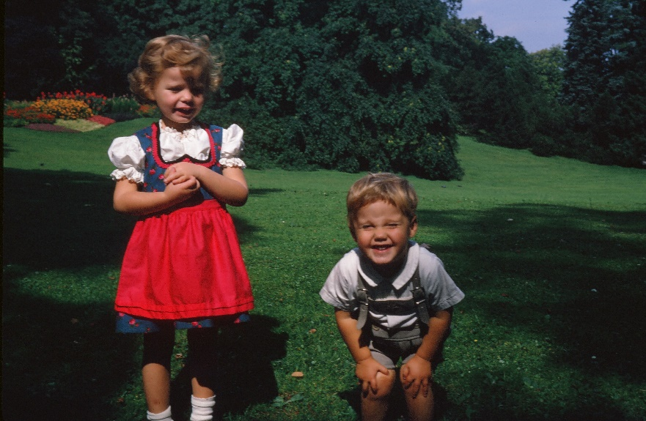
I smile every time I look at it, and I think God does too. Our notions of being child-like need to be expanded to include God’s counter-cultural thinking!!

God’s Counter-cultural Values

From God’s perspective the notion that Christ’s followers are to be humble and trusting and dependent and spontaneous, and imaginative as well as playful is definitely counter-cultural.

In fact, in the realm of academia, to which most of our church members belong, the values there are the very opposite of child-likeness. I ultimately left my job as an Adjunct Professor in Seminary because of the prideful ethos which was evident in the competitiveness, turf in-fighting for seniority and greater concern for status than care for the students. This loss of child-likeness in adult is true in so many professions. We are letting the culture squeeze us into its mold. Yet, child-likeness in thought and behavior is what Jesus celebrates and what represents Him clearly in culture.

Back to Matthew’s gospel. The children who had followed the adults into Jerusalem shouting ‘Hosanna’ to Jesus as their glorious Messiah/King kept on celebrating him with songs even in the temple (Mt. 21:14-16). They were unaware of the crescendoing political hostility the religious rulers had toward Jesus. The children’s trust and joy must have been a delight to the Lord’s heart – a breath of fresh air in countering the stifling hatred and ego-fueled machinations of the religious rulers.

I believe the childrens’ behavior exemplified what Jesus means when he said “Blessed are the poor in heart for they shall see God.” In defining ‘poor in heart’ Cloud and Townsend say: “A good way to understand this is to think of spiritual poverty as that sense of neediness and incompleteness that opens us up to trust wholly in God because we realize how much we need Him. That dependent trust is the child-likeness Jesus is honoring.

Jesus knows it takes courage and great trust in Him as an adult to maintain the total dependence on Him He seeks in our witness. Many other values in our cultures pressurize us to conform to ego-centric, group pleasing and even illegal behaviors in business and life. But we can’t be God’s salt and light in a dark world if Christ is not clearly evident in our character, motivations and actions. Only through the Spirit’s work in us we can be transformed into true counter-cultural witnesses.

So, with Christ’s model in mind, may we be more child-like in our faith, beloved, and be willing to put the childishness of pride and status-seeking at the foot of the cross. May we come to Him to take on Christ’s character. Yes, He has all authority over all evil and He is the Truth and reigning Lord of the universe. Those truths are unchanging and the basis for our confidence in a turbulent world. But He is also gentle and humble in character and in Him alone we find rest for our souls, Mt. 11:29.

May we all grow to be His loving child-like, secure sons and daughters who live out Christ’s countercultural values in this world.

For His sake and the sake of a watching, self-serving world. Amen.
Dr. M.L.Codman-Wilson, New Hope Global pastor 3 7 21

