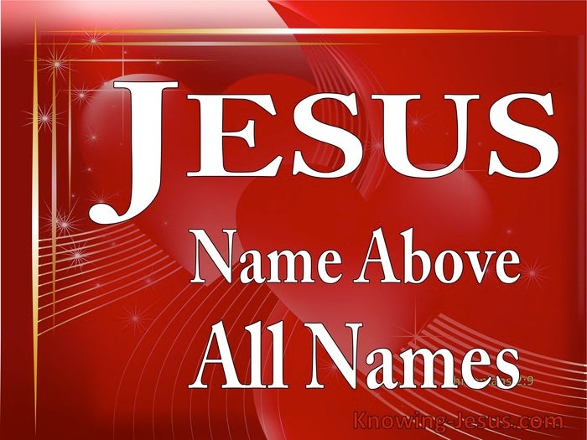
“Jesus, Name Above All Names” 7/10

Opening story: The Lighthouse
The captain of a ship looked into the dark night and saw a light in the distance. Immediately he told his signalman to send a message, “Alter your course ten degrees south.” He promptly received a reply, “Alter your course ten degrees north.”
The furious captain sent another message, “Alter your course ten degrees south. I am a captain!” Soon another reply was received, “Alter your course ten degrees north. I am seaman third class Jones.”
The captain sent a final message, “Alter your course ten degrees south. I am a battleship.” The reply was, “Alter your course ten degrees north. I am a lighthouse” (https://ministry127.com/resources/illustration/i-am-a-lighthouse)
Today we are dealing with who is in authority in this world. That ship captain thought he was in authority because, after all, he was the Captain of his battleship! But he couldn’t see the Lighthouse. Often we may think we are also in authority because we do not see or recognize the presence or power of the evil spirits in our world. And, actually, we cannot “see” Jesus tangibly either. But let me assure you biblically that there are spiritual realities all around us- Jesus, the rulers of this world and spiritual dark forces of evil, and the heavenly host – the millions of angels who are sent as ministering spiritus to serve believers. Our goal today is to open our eyes to see these spiritual realities all around us and learn to recognize and follow the right ones!
Let us pray.

Introduction:
First, the spiritual realities around us.
The good news is that there ARE angels, millions of angels in heaven and as part of the Lord’s army. We met them most famously throughout the Christmas story. They brought announcements from God to both Mary and Joseph, sang in praise at the birth of Jesus, warned Joseph about his need to flee to Egypt with baby Jesus and Mary and when to return to Nazareth. They strengthened Jesus after his bout of temptation with Satan and then at the end of his life when he was wrestling with the horror of his upcoming crucifixion. Later in the New Testament story in Acts, they rescued Peter from prison and his certain death, encouraged Paul several times in his ministry, and were indeed ministering spirits to serve the saints. How many of you remember the popular TV series called Touched by an Angel? It was all based on God’s loving intervention incognito to help his struggling people. Angels are real. Some people mistakenly worship them. But we don’t worship them. Jesus is greater. We worship Him.

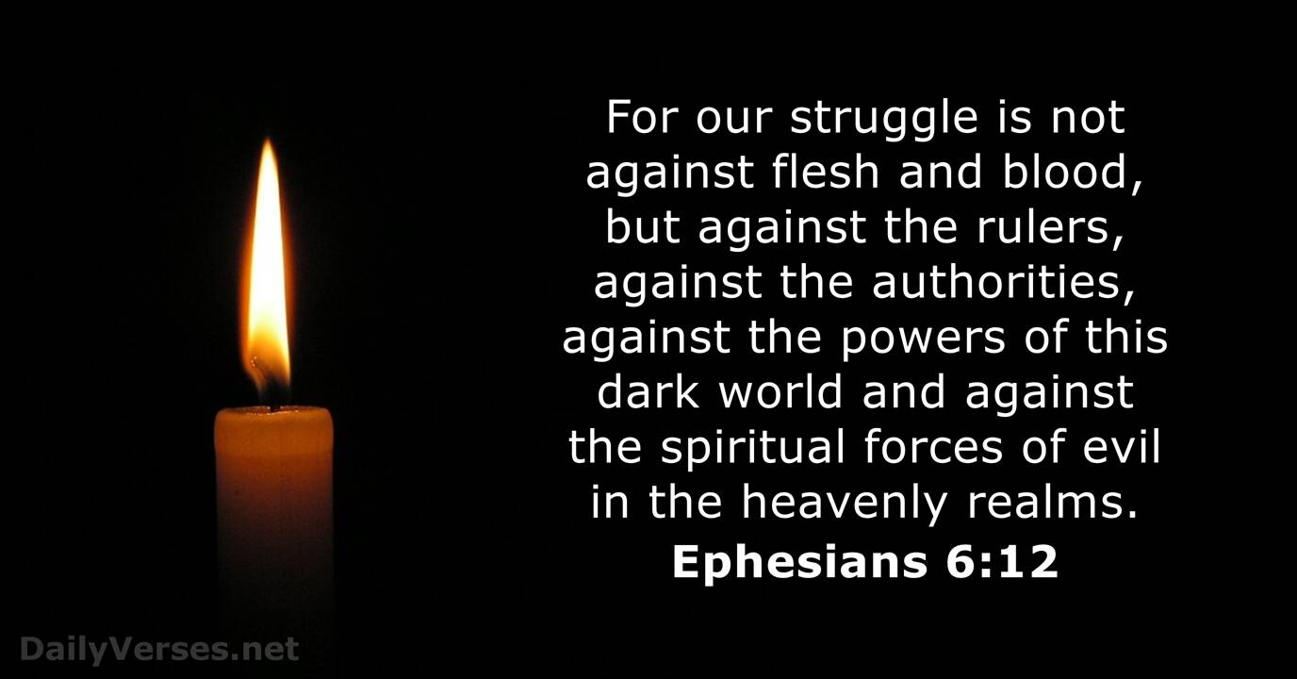
But there are also evil spirits whose purpose in the world is just the opposite – to steal, kill and destroy all God’s purposes and God’s people. We heard about them in the Scripture reading from Eph.6:12.

Some people worship these evil spirits and Satan whom Jesus called the Prince of the power of the air. They do this because in that worship, they receive evil power to prophesy, to control or curse or hurt others, to do some acts of amazement. They think they have power in that role. But actually they become nothing but servants to the evil intentions of Satan and their own lives bear the marks of that devastation.
But we don’t worship Satan. He has been defeated by the One true God – the Lord Jesus Christ. We worship Jesus. Because. . .

He is supreme over all these opposing forces in the spirit realm. His is the Name above all names. As Paul says in Phil 2:
Though he was God,^{[a}he did not think of equality with God as something to cling to. ⁷ Instead, he gave up his divine privileges^{[b]}; he took the humble position of a slave^{[c]} and was born as a human being. When he appeared in human form,^{[d]} he humbled himself in obedience to God and died a criminal’s death on a cross. ⁹ Therefore, God elevated him to the place of highest honor and gave him the name above all other names, ¹⁰ that at the name of Jesus every knee should bow, in heaven and on earth and under the earth,¹¹ and every tongue declare that Jesus Christ is Lord, to the glory of God the Father. NLT
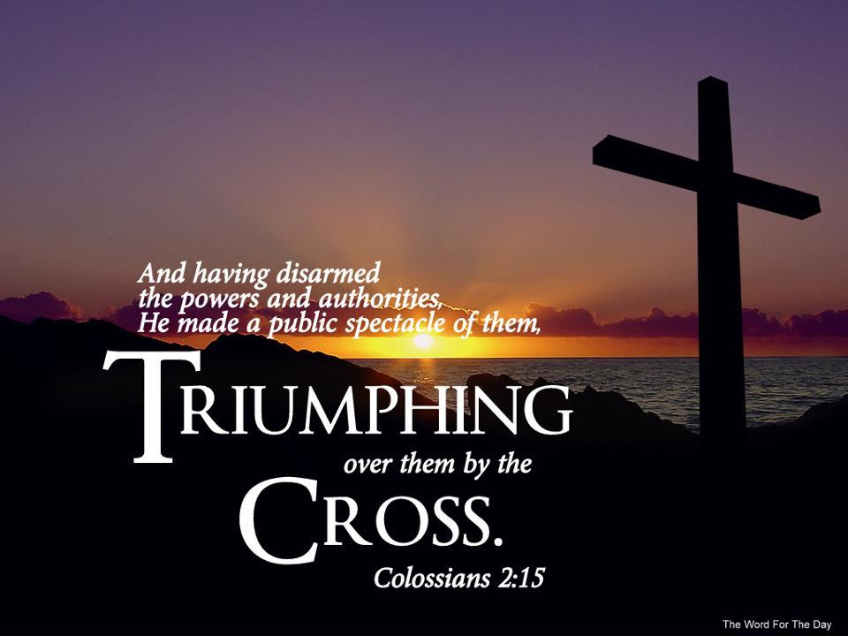
At the name of Jesus every knee shall bow and every tongue declare that Jesus is Lord! Jesus is the King of Kings and Lord of Lords.

This is the glorious good news of the gospel, but in Colossians two Paul explains how Jesus has defeated Satan and the difference it makes for our lives. This is the point I want to emphasize today. Colossians 2:15 says Christ triumphed over every evil power and authority by the Cross. That is where he nailed all the demands of the law against us and all the powers of evil which accuse us. They have been put to death there. This includes every spirit of depression, of oppression that feels like it is suffocating us, every infirmity and sickness, every spirit of anger and rage and gossip and slander, every spirit of revenge and pride and warfare and dehumanization, every spirit of self-pity, and woundedness, every party spirit that comes to split up churches and families and nations. You can add so many other negative, destructive spirits to this list. But Jesus has nailed them all to the cross, and triumphed over them. That is what I pray each time I resist Satan and all his evil forces with this word of my testimony (from Col. 2:15), and the blood of the Lamb (Rev. 12:10-11). This is how we resist when Satan attacks and why he must flee (James 4:7, I Peter 5:8-9). What a word of hope and victory in this dark time.
But note also that he disarmed principalities and powers. When we claim this verse by the power of God, we realize that the viciousness of their power has been stripped away from them by Jesus the Victor! As we acknowledge these truths of the Gospel and claim the blood of the Lamb (Rev. 12:11), we defeat the enemy whose whole purpose is to defeat us!!

A True Story
Now let me put all these forces together and show how this applies in real life. Really, beloved knowing the truths of the gospel is essential but not life-transforming UNLESS we apply them. So I will always stress application each week as we are on this journey of Living Jesus together.
Here’s the story:
A missionary doctor was serving the Lord in a remote hospital deep in the savannah of Africa. He didn’t have a vehicle so every month, at the beginning of the month, he would walk for two days to the nearest town where he could withdraw a sizeable amount of money from the bank to pay the hospital employees. Over time the town thugs caught on to his monthly routine. One spring on the first day of the month, they decided that they would follow the doctor on his way back to the hospital and when he lay down in the open for the night, they would rob him. They waited in town to be sure he came to the bank, and when he did and headed back to the hospital, a group of tough men trailed him, being careful to keep out of sight. The missionary laid a small fire at the place where he intended to sleep, spread out his blanket and as dark descended, lay down close to the fire and fell asleep. The men inched closer.

But they weren’t able to rob him. The next month, the leader of the gang approached the doctor when he came to town and said, “Doctor who were the men you had circled all around you last month as you slept on the ground?” The doctor looked puzzled. “I didn’t have anyone with me,” he said. “Oh yes you did,!” replied the thug – “12 very large men who had on bright clothes and were encircling you with drawn swords in their hands!”

The doctor didn’t think any more about it until a couple of months later when he returned home on furlough and was speaking at his home church. To his surprise, the gang leader’s question came to his mind and he shared the story but added, “I wonder what the gang leader was talking about?” An elder in the church stood up and asked, “Doctor what day and month did this happen?” The doctor replied “On the first Tuesday of June.” The elder continued, “The morning of that day I suddenly had a very strong impression that you were in some kind of trouble and we needed to pray for you. The impression kept getting stronger and stronger until I called some other men in the church and asked them to come to the church and meet me for prayer immediately. Would all the men involved in that spontaneous earnest prayer time please stand up?” One by one eleven other men rose to their feet.

The angels that were encircling the missionary that Tuesday came to the doctor’s rescue because Jesus had already disarmed the principalities and powers and the men knew to pray in Jesus’ name against whatever was causing danger to the doctor. The doctor never saw the angels as he slept. But those with their evil intent certainly did and that scared them away. They never tried to rob or kill him again! Angels, principalities and powers, Jesus’s authority and Christians who took that authority to disarm Satan’s powers and foil their attempt. These are the forces at work in that true story. And this is how it all fits together, beloved. We don’t have to cringe or feel hopeless and powerless against Satan’s attacks. We claim Christ’s power because Jesus has risen from the dead and risen triumphant over every authority, power of this dark world, and the spiritual forces of evil in the heavenly realm. In Christ’s name and blood, we can too. Amen and Amen.

Dr. ML Codman-Wilson 7 10 22.
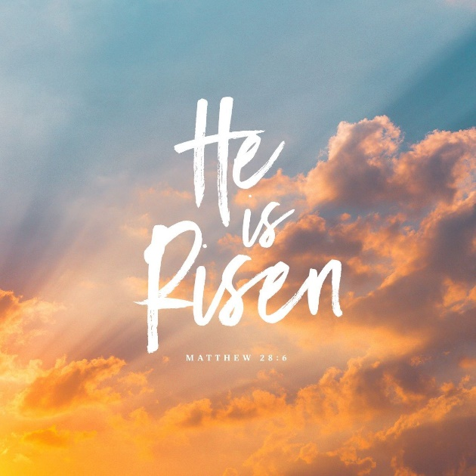
Our hymn of response is the song: Fight the Good Fight, #307, verses 1, 3 and 4. It is a song of truth, of faith and an application you can apply this week!

Pastoral Benediction

Song of Going forth – Because He lives.

