New Hope Global Sermon “Come, Follow.” Joshua 3:-6

Introduction
There are hundreds of Christian books on the subject of God’s guidance and probably at least that many on the obedience demanded by God of followers of the Lord Jesus. Our theme today of “Following God” is divided into two parts. It starts off in Joshua 3 as the people of Israel prepare to cross over the Jordan River to begin their conquest of the Promised Land. Then it moves to chapters 4-6 as Joshua himself continued to follow God’s lead when that leading transcended common sense.

In Part One I found five steps involved in guidance that the Israelites experienced as they became part of the miracle embedded in crossing the Jordan River. Here is that Scripture:
3 Early the next morning Joshua and all the Israelites left Acacia Grove^{[a]} and arrived at the banks of the Jordan River, where they camped before crossing. ² Three days later the Israelite officers went through the camp, ³ giving these instructions to the people: “When you see the Levitical priests carrying the Ark of the Covenant of the Lord your God, move out from your positions and follow them. ⁴ Since you have never traveled this way before, they will guide you. Stay about half a mile^{[b]} behind them, keeping a clear distance between you and the Ark. Make sure you don’t come any closer.” ⁵ Then Joshua told the people, “Purify yourselves, for tomorrow the Lord will do great wonders among you. . . . ¹⁰ Today you will know that the living God is among you. He will surely drive out the Canaanites, Hittites, Hivites, Perizzites, Girgashites, Amorites, and Jebusites ahead of you,” (Josh. 3:3-10, NLT).

1..v. 3-4 – they are given instructions about how to know when to move out.

2. v. 5 –- they are commanded to consecrate themselves to the Lord as part of their preparation to move.

3. v. v5. they are told a miracle will happen if they obey.

4 v. 10 – they are told that the miracle would assure them that the living God was living among them and that God Himself would drive out the inhabitants before them so that Israel would take sole possession of the land.

5. v.14-17 – the people actually watched the miracle take place, as the waters piled up at the mouth of the Jordan River and they experienced the miracle for themselves as they walked across the River bed on dry ground!
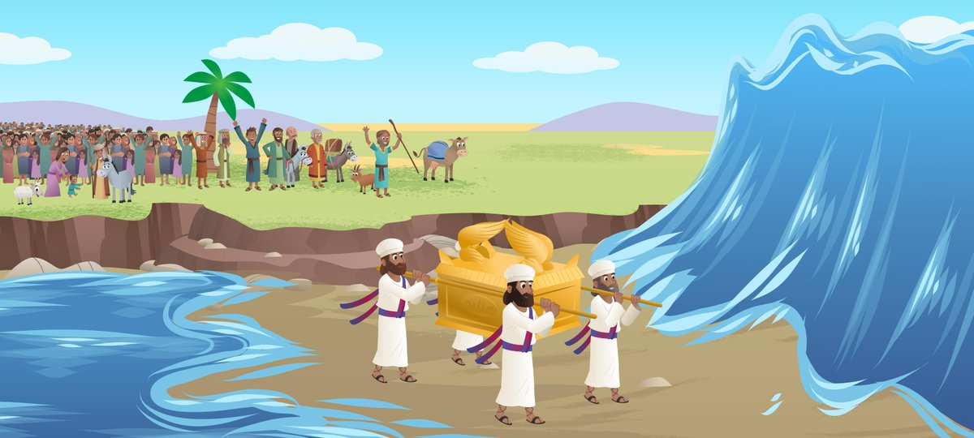
Let’s look at the implications of each of these 5 stages more closely. As I have been personally living this story in the last 2 1/2 months, I will illustrate the process from my own life.
First, I want to emphasize the truth that the Lord is still seeking to do miracles in each of our contexts – despite what may seem impossible. NOTHING is impossible with God. Therefore, the importance of step 2 is a priority– to consecrate ourselves in readiness for God’s work among us. May God give us an expectant faith and eyes and heart to recognize where and how God is moving. God made it very clear for Joshua (step one) and He can be moving in our hearts in the same way – to give an urge for action, a sense of direction about what that entails, assurances to confirm that leading, and the words of scripture that accompany that direction.
For me, when I went to the Ogden Dunes church in Indiana to preach there April 24th, the Lord gave promises, gave me a deeper passion in preaching than I had felt in years, brought back to me His original calling for me from Ephesians 3:7-8, and gave me His anointing as I preached, the acceptance by the people, and a definite longing to return. All that has set in motion a new direction and blessing for that church and for me. It is certainly a miracle considering this stage of my life, Keith’s deteriorating health and all that has and hasn’t happened since we returned to Wheaton a year ago.
So, in response to this leading and open door of invitation from the church, I now am very intentional to keep listening for God’s leading week by week and claiming the victory in all Satan insinuates negatively in my mind or attacks in my body to take away this call. My job as week flows into week is to keep my own heart close to the Lord so I can lift up Jesus for the people and celebrate the Lord’s movement among us. As I keep the promises and calling of God before me, I go forward in faith.
Interestingly in step 5, the Israelites were camping beside the Jordan for 3 days before God began to back up the waters. So they saw the river at flood stage. It would have made the thought of crossing the Jordan seem impossible. But they saw the waters backed up; they crossed over on a dry river bed to the other side, and they witnessed the flood waters return after the nation was safely on the Promised Land side. They lived the miracle God had promised.
To continue the simple analogy in my case in terms of what seemed impossible and why a miracle was needed, I experienced the difficulty of making connections with people in my first year back in Wheaton because of Covid. As a result, no house church has emerged, no vibrant grad student ministry isn’t taking place; the ministry I had hoped for hasn’t materialized; and I certainly had no hopes or dreams of being a part-time interim pastor out of the area. But I kept calling out to God to lead me. And now God is doing it in a way I never could have anticipated.
And that’s the encouragement I want to pass on for all of you.
A couple of big-picture principles in summary from the Jordan River crossing are:
- Note that this story is in the context of a group (a nation) who are following God and the leader Joshua. Although the principles apply individually, remember they are in a group context. That is important as a corrective for our individual leading which may be following our own wisdom, not God’s. The group context gives a check and balance.
- God still is seeking people who follow Him so He can work miraculously in their midst for His kingdom agenda.
- God will use His Spirit’s nudges, His Word, the affirmation of other people, and our own sense of peace and joy as we watch Him work.
- Our part in this miracle process is faith, whole-hearted obedience and a glad witness to His work.
Part Two: Following God when His directions contradict common sense
But the story of following God goes on in Joshua’s life as God’s instructions seem to contradict common sense, and yet still Joshua followed. In large brush strokes, let me summarize 3 more examples of the obedience of Joshua to follow God’s lead from chapters 4-6.

Story #1 = Crossing the Jordan River. Before the Israelites went into Canaan the “land was bounded by the Egyptian Empire to the south and the Assyrian empire to the north, but settled by 7 Canaanite tribes who inhabited 31 fortified city-states, each ruled by its own king,” (Ken Spiro “Crash course in Jewish History” #14 @aish.com). To take the land the Israelites had to conquer each of these city-states. There were overwhelming obstacles, so it was a task only God could help them accomplish. God told Joshua, “Moses my servant is dead. Now you and the people are to cross the Jordan River into the land I am about to give you.” And God told him exactly how it was to happen. This is the Joshua 3 story mentioned earlier. Remember, God said the priests are to carry the Ark of the Covenant into the Jordan River first and stop – the waters will part and all the people will pass “by the priests, standing on dry ground in the middle of the river bed.” 3:17. It sounded so simple, but it must have been a bit terrifying – for both Joshua and the people - just like crossing the Red Sea on dry ground had been for their parents. Yet, Joshua 4:14 says “that day the Lord made Joshua great in the eyes of all the Israelites and for the rest of his life they revered him as much as they had revered Moses.” God had made the miracle possible; Joshua had merely carried out God’s instructions even when it had seemed impossible– a lesson for us too, yes?
Story #2 – Gilgal. Once the people were in the Promised Land in Gilgal, Joshua made sure they obeyed the commands of God. So, at God’s directive, he had all the males of this new generation circumcised. Circumcision was given to Abraham as a sign for God’s covenant people but the disobedient generation who died in the wilderness hadn’t been faithful to God in this. Now the Israelites were in enemy territory, if you will, so militarily this made no sense at all. In fact, it made all the males very vulnerable for 3 days, but still Joshua kept the command of the Lord and all the sons of the entire generation who had died in the wilderness were circumcised at Gilgal. Then the nation celebrated the Passover. It was the first time this festival had been kept for 40 years. Joshua was teaching the people to follow God first by obeying His word. As a result, God said their reproach of slavery in Egypt was rolled away. And the day after the Passover, the manna stopped (Josh. 5:12) the land itself would now provide their sustenance. Another lesson for us in our priorities – put God first and He will take care of us and bless us. The conquering of the city-states could begin.
But before that happens, God wanted to make sure Joshua knew who was in charge. Chapter 5:13 says “As Joshua approached the city of Jericho, he looked up and saw a man facing him with sword in hand. (That’s a bit intimidating!) Joshua went up to him and asked, ‘Are you friend or foe?’ "Neither one," he replied. ‘I am commander of the Lord's army.’ At this, Joshua fell with his face to the ground in reverence. ‘I am at your command,’ Joshua said. ‘What do you want your servant to do?’ The commander of the Lord's army replied, ‘Take off your sandals, for this is holy ground.’ And Joshua did as he was told” (Josh. 5:13-15 NLT).
This incident reminded Joshua and the people of God’s appearance to Moses in the burning bush and it made clear “who was fighting for whom. Yahweh did not fight for Joshua, as if Yahweh was at Joshua’s command. Instead, Yahweh’s army retained its independence with Joshua fighting for Yahweh,” (Reading the Old Testament, ch.6). When Joshua fell down in worship, he was ready to hear God’s instructions for taking Jericho. That’s another application point for us – we can hear God’s instructions when we meet God in worship.
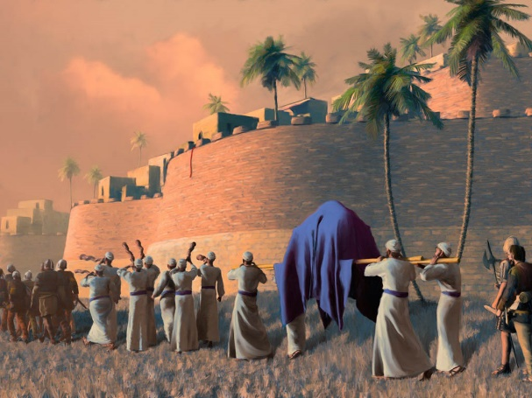
Story #3 – Jericho. And that’s crucial because, here again, God’s directions made no sense. Remember Joshua was an experienced successful military man. But God said the people were to march around the city once a day for 6 days with the priests in the lead blowing their horns. For the seventh day they were to march around the city 7 times with the priests blowing the horns. Then, God said, ‘when the priests give one long blast on the horns, all the people are to give a mighty shout, the walls of the city will collapse and the people can charge straight into the city,” (Josh. 6:3-5). That seems to be insane military strategy, because those inside the fortified city of Jericho could shoot the Israelites as they marched around beneath then, but Joshua obeyed. God was in charge and the walls of Jericho fell. The Israelites conquered their first city-state because it was done God’s way. Chris Tomlin’s song “I Will Follow” comes to mind as we apply each of these truths today:
Refrain: Where You go, I’ll go, where You stay, I’ll stay, when You move, I’ll move, I will follow.
All Your ways are good, all Your ways are sure, I will trust in You alone. Higher than my sight, higher above my life; I will trust in You alone. Refrain. Light into the world, light into my life, I will live for You alone. You’re the One I seek, knowing I will find, all I need in You alone.
Refrain: Where You go, I’ll go, where You stay, I’ll stay, when You move, I’ll move, I will follow. Whom You love, I’ll love, how You serve, I’ll serve; if this life I lose, I will follow You. I will follow You. In You there’s lie everlasting. In You, there’s freedom for my soul. In You there’s joy, unending joy; and I will follow. Refrain: Where You go, I’ll go, where You stay, I’ll stay, when You move, I’ll move, I will follow. Whom You love, I’ll love, how You serve, I’ll serve; if this life I lose, I will follow You. I will follow You.
May God give us the courage and the expectant faith to go or stay or move as He directs and to follow the Lord even when the directives transcend our common sense. May God also give us the empowerment to love and serve as He does. All for His sake. Amen. Dr. Mary Lou Codman-Wilson Pastor New Hope Global Fellowship 6 29 22

