Weekly Sermon - The Birth of the Church : No More Stained Glass Christians, October 16 22

Stained Glass Religion
Are any of you lovers of stained glass as I am? I have several stained glass pieces in my home, one, a piece I commissioned by a stained glass artist in Colorado! I love the colors, the creativity, the beauty of just looking at these works of art and appreciating the artists who have created them. One of my delights in Florida was visiting a stained glass museum in Winter Park, north of Orlando. It was dedicated to Louis Tiffany’s stained glass works. This piece was in his dining room in Laurelton Hall, Tiffany's Long Island estate. Or this smaller piece:

There were many of his famous lamp shades as well! This lamp shade is priced at $8,000.00! The museum took up almost a whole city block and fitting to the beauty it evoked, even had a courtyard within the museum filled with trees and flowers and benches so people could go from contemplating the beauty in the glass to contemplating the beauty in nature.

In art stained glass has an extraordinary place. Among religious people, however, not so much. Why? I learned the answer personally. My days in ministry in the 1980s were as the Mission Coordinator at our large Presbyterian church in Baltimore. We were discipling college students and watching them flourish in the Lord. I loved it. Then I was called to come to Wheaton (after Keith took an early retirement), and work nationally for the Association of Church Missions Committees called ACMC. To send us off to Wheaton, our team of grad leaders in the Baltimore ministry gathered around Keith and me and prayed this prophetic prayer for me: “Mary Lou, don’t be a stained glass Christian – one whose works point to you and draw attention to your ministry. Then all the attention is on you. God is calling you to be transparent glass, so people can see Jesus alive in you. Then you can bring them to Him.” A transparent glass Christian, not a stained glass Christian. This issue is directly related to the birth of the Early church at Pentecost. Let us pray.

The Context for Pentecost

The context for Pentecost in Jesus’ day is that the religious leaders in Judaism were stained glass people. Jesus indicted them for performing their religious acts so others could see and applaud them. The acts were not bad – they were good acts of piety and service. But here’s how Eugene’s Peterson translated Jesus’ rebuke to them: From Mt. 6:1-6:

¹“Be especially careful when you are trying to be good so that you don’t make a performance out of it. It might be good theater, but the God who made you won’t be applauding. ²⁻⁴ “When you do something for someone else, don’t call attention to yourself. You’ve seen them in action, I’m sure—‘playactors’ I call them—treating prayer meeting and street corners alike as a stage, acting compassionate as long as someone is watching, playing to the crowds. They get applause, true, but that’s all they get. When you help someone out, don’t think about how it looks. Just do it—quietly and unobtrusively. That is the way your God, who conceived you in love, working behind the scenes, helps you out.
⁵ “And when you come before God, don’t turn that into a theatrical production either. All these people making a regular show out of their prayers, hoping for fifteen minutes of fame! Do you think God sits in a box seat? ⁶ “Here’s what I want you to do: Find a quiet, secluded place so you won’t be tempted to role-play before God. Just be there as simply and honestly as you can manage. The focus will shift from you to God, and you will begin to sense his grace.

The Holy Spirit came as fire in the birth of the church at Pentecost to cleanse the church of any showmanship or stained glass religion from the very beginning. The focus had to be all on Christ, who He is, what He had done, and people’s response to his offer of salvation. The early church leaders who preached that new teaching had to be transparent Christians so people’s response was to Jesus, not to them. That’s the context of the birth of the church.

You shall receive power
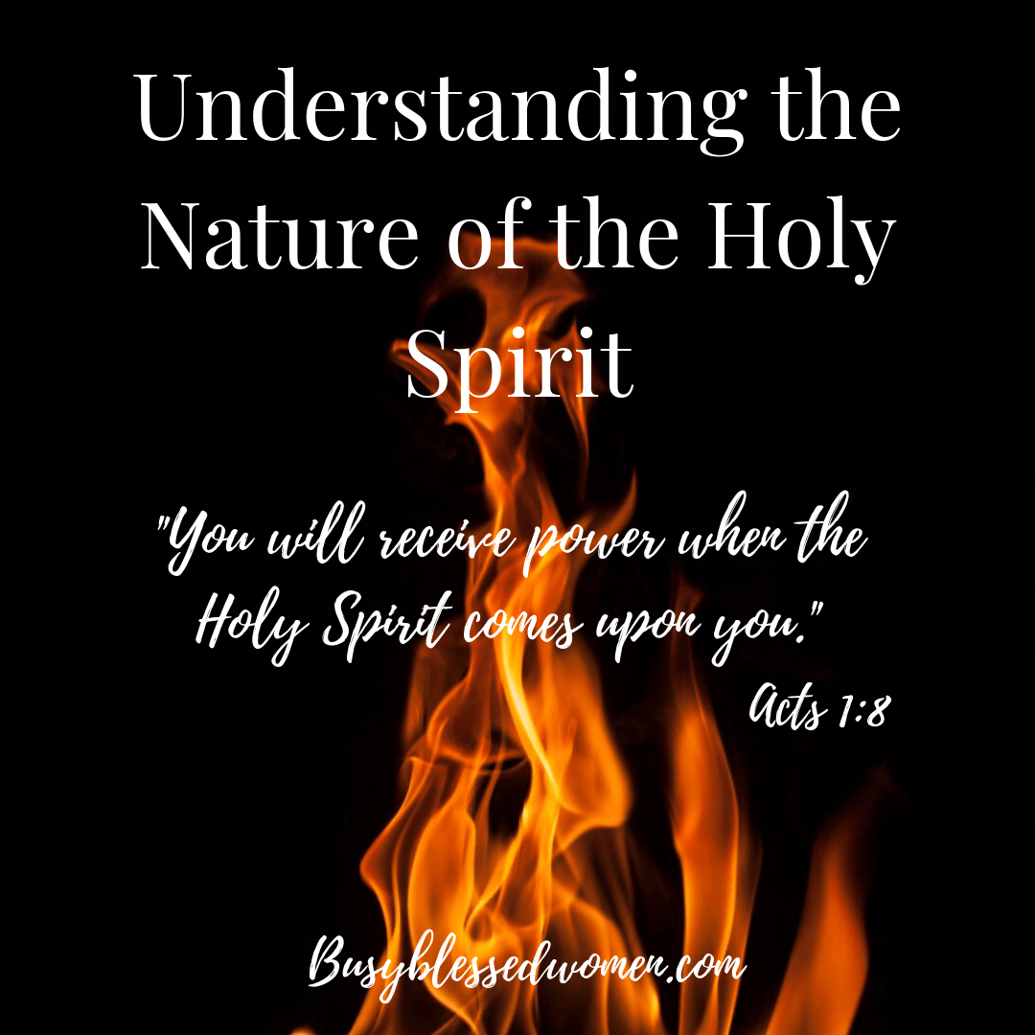
Our key text today is Acts 1:8 “You will receive power when the Holy Spirit comes upon you.” The symbol of the Spirit this week is fire. It is associated with the cleansing, the power, and the wisdom needed for the church now to thrive.
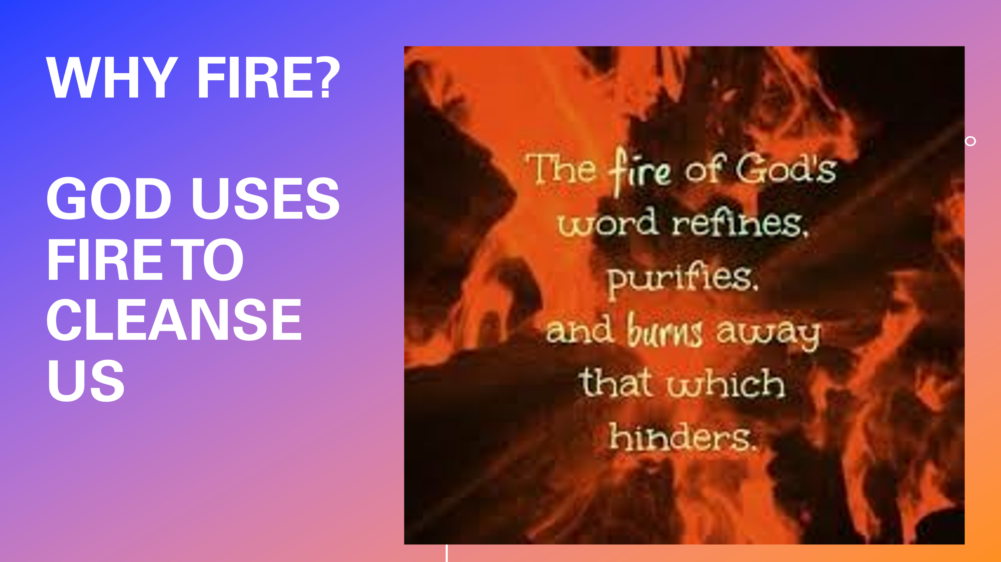
Why fire? Answer #1.

In the Bible God is referred to as a Refiner, One who purifies and burns away anything which hinders the purity and witness of the believers and witness of His people.

The Bible mentions this through both the O.T. prophets Zechariah and Malachi. The Zechariah passage refers to the cleansing of the remnant who will be left in Israel to serve the Lord: Zech. 13:8-9:

“Two-thirds of the people in the land will be cut off and die”. “But one-third will be left in the land. ⁹ I will bring that group through the fire and make them pure. I will refine them like silver and purify them like gold. They will call on my name, and I will answer them. I will say, ‘These are my people,’ and they will say, ‘The Lord is our God.’”

The Malachi passage says similarly:
3 “The messenger of the covenant, whom you look for so eagerly, is surely coming,” says the Lord of Heaven’s Armies.² “But who will be able to endure it when he comes? Who will be able to stand and face him when he appears? For he will be like a blazing fire that refines metal, or like a strong soap that bleaches clothes. ³ He will sit like a refiner of silver, burning away the dross. He will purify the Levites, refining them like gold and silver, so that they may once again offer acceptable sacrifices to the Lord. ⁴ Then once more the Lord will accept the offerings brought to him by the people of Judah and Jerusalem, as he did in the past. NLT
The need for cleansing by fire was God’s intent to transform His leaders in the new church from being stained glass people to being transparent people who reveal Jesus. The stained glass emphasis on doing what will show off oneself, and draw admiration and attention from people is over. God wanted people with a purified heart to be His representatives. That’s the Holy Spirit’s work as fire #1.

Why fire? Answer #2:
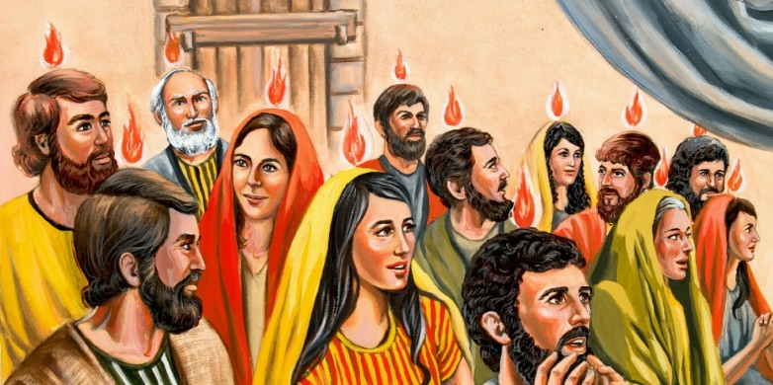
Fire also represents the power needed to fulfill Christ’s mandate – to be His witnesses. At Pentecost, tongues of fire appeared on each believer in that gathering, as the graphic illustrates. Fire to speak with power. Power to even speak in other languages.
And that’s what happened. When the Holy Spirit came on them, they spilled out into the streets to speak clearly and courageously about Christ. Here is the Acts account:
At that time there were devout Jews from every nation living in Jerusalem. ⁶ When they heard the loud noise, everyone came running, and they were bewildered to hear their own languages being spoken by the believers. ⁷ They were completely amazed. “How can this be?” they exclaimed. “These people are all from Galilee, ⁸ and yet we hear them speaking in our own native languages! ⁹ Here we are—Parthians, Medes, Elamites, people from Mesopotamia, Judea, Cappadocia, Pontus, the province of Asia, ¹⁰ Phrygia, Pamphylia, Egypt, and the areas of Libya around Cyrene, visitors from Rome ¹¹ (both Jews and converts to Judaism), Cretans, and Arabs. And we all hear these people speaking in our own languages about the wonderful things God has done!” ¹² They stood there amazed and perplexed. “What can this mean?” they asked each other. NLT

God still gives the power of witness in other languages. I read a story of a Wycliffe pilot who had to make a dangerous trip to rescue people in a remote village in the mountains of South America. He did not know the heart language of the people of that tribe and they did not know the national language used throughout the country. Yet when the pilot landed, he could sense the distress among the people about the child who was terribly sick and needed to be airlifted to a city which had a hospital. He wanted to speak words about Jesus Christ as a healer so the people could find Jesus in this crisis. He opened his mouth and suddenly found himself communicating without problem in their local language. His message was welcomed, and believed so that before the child, village elders and the child’s parents were airlifted from the village on his plane, they had committed their lives and the life of their child to Jesus. God gave him supernatural power to speak a language he didn’t know so people could come to faith in Christ! (PP)

In addition, the Holy Spirit’s power to witness helps us speak about Him to those outside our social circles or those with whom we feel estranged. There are times God’s power is needed for us to communicate His love when our own assessment of the situation silences us. This happened to me with a person I had been close to but who walked away from the Lord. We lost touch, lived in different cities and lived very different lifestyle priorities. Yet after some years of being separated, we were in the same place at the same time with no one around. I heard the prompt “Ask Beth how she is doing?” Not knowing yet this was the Spirit speaking to me, I countered with my rationalizations: “Bad idea – she doesn’t trust me. Bad timing – others will come and we won’t be able to have this conversation. Bad idea.” However, the inner voice came to me again, this time with the words of warning: “Sometimes I only speak once.” With that warning, I recognized the Spirit’s leading so I took courage and asked Beth how she was doing. I found out she was on the verge of an affair, was drinking heavily, and was considering suicide. How was she doing? Terribly. We were able to continue our conversation the next day and by the Spirit’s power I told her the Prodigal son story of God’s forgiveness and she came back to the Lord. She has walked with Him ever since. However, that weekend, she was suicidal and I believe if I had not obeyed the Spirit’s prompt and trusted the Spirit’s power to give me right words, she would not be alive today. Sharing Jesus with Beth took Holy Spirit power to witness.

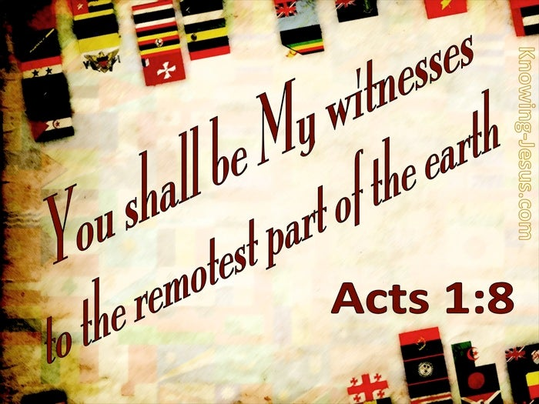
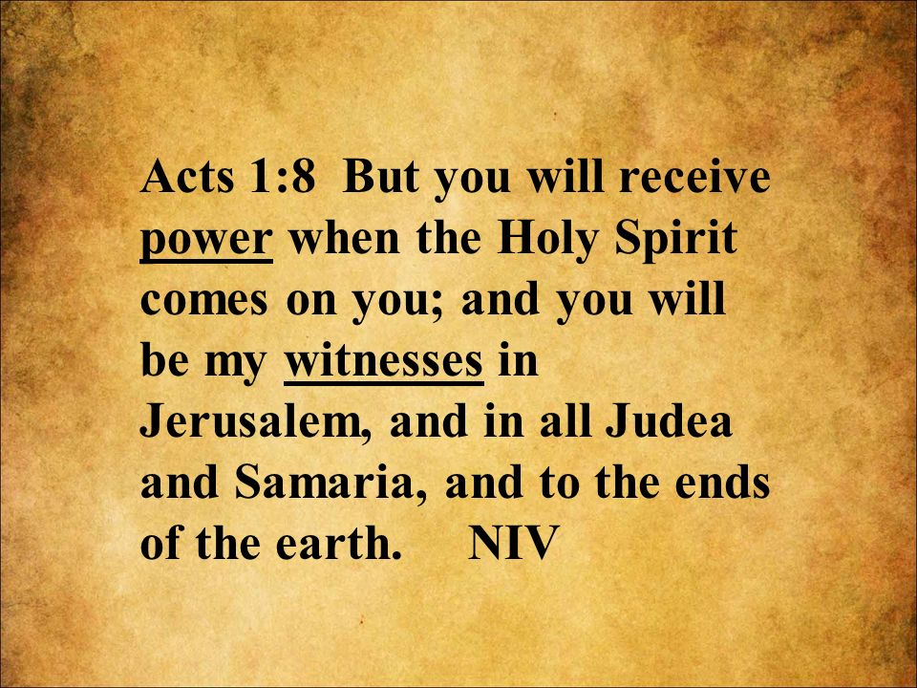
In the promise in our text, Jesus said He would send the gift of the Holy Spirit on the disciples SO they would be His witnesses around the world. To the disciples in Jesus’ day he explained it in ever broadening geographical terms. (PP) Witnesses were to start in their home turf of Jerusalem, then expand to those close by in disdained Samaria, then in the wider territory of Judea, and finally to the ends of the earth – (PP) This second graphic bordered with some of the world’s flags communicates that global reach. Matthew records this same directive from Jesus in Mt. 28 when he says His followers were to go in His authority to bring the gospel, teaching, baptizing, and discipling people from “all nations.”

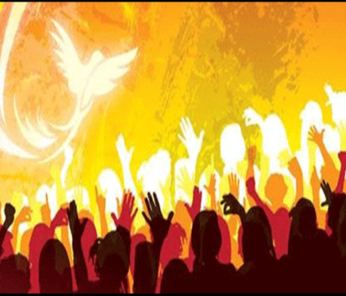
All this becomes the basis, beloved, for (PP) the birth of the church. The Spirit gave each believer present that day the tongues of fire and power to witness. In heart languages that reached each religious Jew in that gathering. And then the Spirit gave Peter the power and right words to preach the good news about Jesus in the context of His people. He started off with the Spirit’s wise words from an Old Testament prophecy they would know: Acts 2: 14-18:
“Then Peter stepped forward with the eleven other apostles and shouted to the crowd, ‘Listen carefully, all of you, fellow Jews and residents of Jerusalem! Make no mistake about this. ¹⁵ These people are not drunk, as some of you are assuming. Nine o’clock in the morning is much too early for that. ¹⁶ No, what you see was predicted long ago by the prophet Joel: ¹⁷ ‘In the last days,’ God says, ‘I will pour out my Spirit upon all people. Your sons and daughters will prophesy. Your young men will see visions, and your old men will dream dreams. ¹⁸ In those days I will pour out my Spirit even on my servants—men and women alike—and they will prophesy.”

From the common background of his audience, then Peter segued to Jesus Christ, and their guilt in killing Him. Finally, when the people were cut to the heart, asking what they should do, Peter said, 3:38 “Each of you must repent of your sins and turn to God, and be baptized in the name of Jesus Christ for the forgiveness of your sins. Then you will receive the gift of the Holy Spirit.”
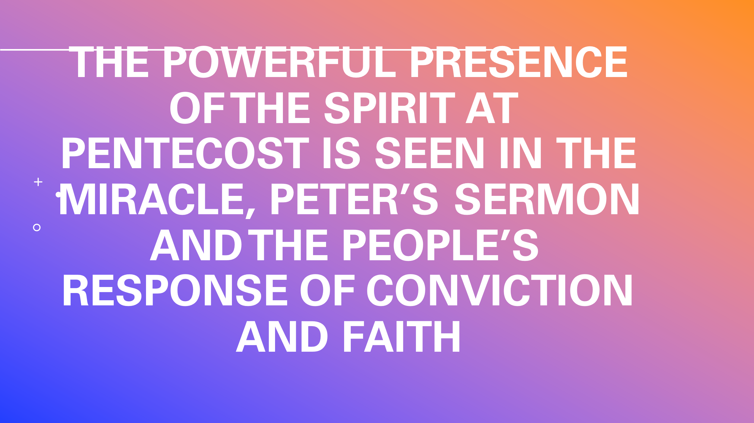
And that began the birth of the church in Jerusalem. All that follows next in the book of Acts records the miracles, the courage, and the stories that follow as the church begins to expand. Pentecost launched the birth of the church! It was evident in the miracle, Peter’s sermon, and the people’s response of conviction and faith (PP).

Our application for today is in the words of our closing hymn: Breathe on me, breath of God #316. To help us sing words from our hearts as a prayer to the Spirit, I invite you to get out your hymnal, turn to #316 and we will SAY together v. 1 and 3. Then we will rise and sing it as Libby accompanies us. Breathe on me. Breath of God. Amen. (PP).

Dr. Mary Lou Codman-Wilson, Guest Preacher at Ogden Dunes Community Church. 10/09/22
Pastor: New Hope Global Fellowship

