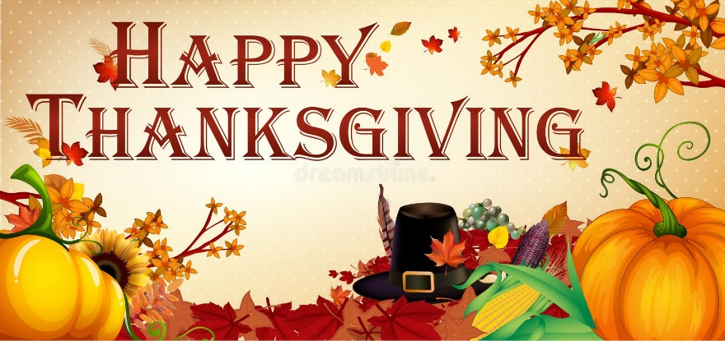
Thanksgiving sermon Nov. 20 2022

I’d like to open within another story of thankfulness=
Community Harvests Crops for Injured Farmer
When Minnesota farmer Scott Legried wasn't able to harvest his soybean crop, more than a dozen people showed up to get the job done. Scott was seriously injured in a car accident when he swerved to avoid hitting a puppy in the road. Scott went off the road, and ended up breaking his collarbone, a shoulder blade, and seven ribs; cracking two vertebrae, and sustaining a collapsed lung and concussion.
Doctors said he wouldn't be able to get on a tractor for several months. This was a problem because Scott runs his farm in the town of Frost almost entirely on his own, and the harvest from his 600 acres of corn and soybeans is his lone source of income. Once word spread in Frost—population 198—of what happened, one neighbor was able to recruit 18 farmers to help Scott. They arrived at Scott's farm with their equipment and in no time had the soybeans harvested. They will come back again for the corn.
Scott said, "This is a busy time of year for farmers, so it meant the world to me. But I guess I really wasn't surprised. I'm lucky to live in a community where people have always looked out for each other.”
In the same way, when the church family lovingly helps each other, it serves as a powerful testimony to the world of Christ’s sacrificial love (John 13:34-35).
Source: Catherine Garcia, “Minnesota community comes together to harvest crops for injured farmer, The Week (10-19-22); Cathy Free, “A farmer was injured saving a puppy. His town rallied to bring in his harvest,” The Washington Post (10-18-22)
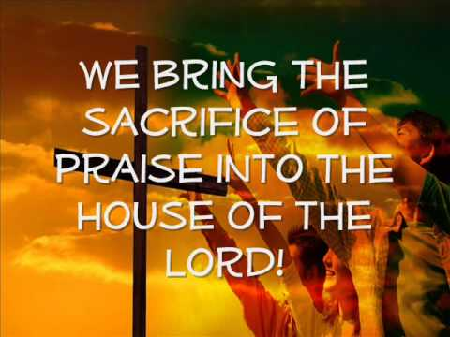
But we used as our scripture today the admonition from Hebrews to “bring the sacrifice of praise into the courts of the Lord” and sang We Bring the sacrifice of praise. Why is it called a sacrifice? Because often in faith we need to praise God in the midst of the hardships of life – not being thankful for the hardships per so but for the God who carries us through them and works all things together in His goodness and mercy for His kingdom expanse in the world.

This Thanksgiving many of us have faced loss, suffering, uncertainties, unexpected death and many reverses in our lives and in the world. So how do we reconcile the command to give thanks always and bring a sacrifice of praise to the Lord with the reality of suffering which has been at the forefront of our lives this past year?. This has been my experience this year and I know it has been true for many of you as well. The question is How could a good God allow so much suffering?
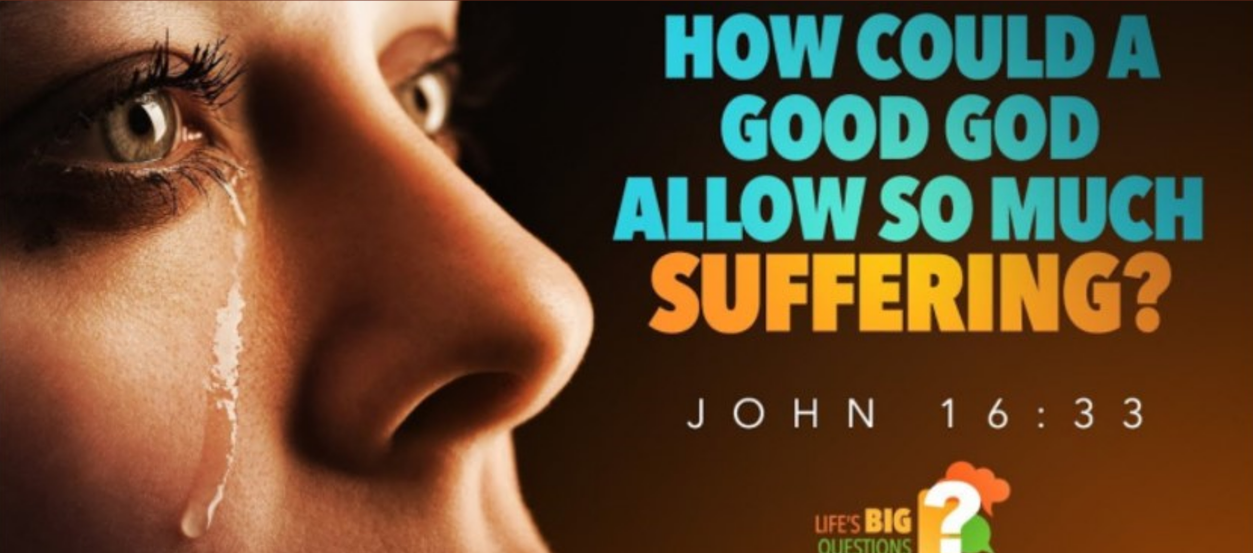
The context in the graphic is John 16:33 – words spoken by Jesus Himself right before the horror of His own incredible sacrifice in death for the sins of the whole world. In these final hours at the Last Supper before his betrayal, scourging with rods and crucifixion He tried to prepare His disciples for what was about to happen. He told them He was going away but would prepare a place for them to join Him after their own deaths. Jn. 14. He told them He would send the Holy Spirit to them after His death. He told them He would rise from the dead after 3 days and they would see Him again. He told them of their own impending trouble and suffering in the world. All of which happened soon after or would happen in the centuries to follow. He told them that Satan, the Prince of this world was coming but he has no hold on me.” Jn.14:36).And He told them to “take heart (despite all the trouble they would have in the world) for “I have overcome the world.” (Jn.16:33).

And in those words, we get a glimpse of the power of God’s sovereignty and the reason why we can still give a sacrifice of praise in the midst of the suffering that may have marked this past year. It is the victory seen in the two little words: “BUT GOD.” God’s final word over all the evil and suffering in the world is that He has won the victory. Satan and all the powers of evil were defeated in Christ’ cross and resurrection and that victory is available for all His disciples over all the centuries. That is God’s bottom line.

And it can be ours as well. There is sin. There is death. But as Paul says in I Cor. 15:56-57 “The sting of death is sin and the power of sin is the law. But thanks be to God! He gives us the victory though our Lord Jesus Christ.” NIV. The Passion Translation puts it this way:
“It is sin that gives death its sting and the law that gives sin its power. But we thank God for giving us the victory as conquerors through our Lord Jesus, the Anointed One. “
[Paul then explains the result of this victory]: “So now beloved ones, stand firm, stable and enduring. Live your lives with an unshakeable confidence. We know that we prosper and excel in every season by serving the Lord, because we are assured that our union with the Lord makes our labor productive with fruit that endures.” I Cor. 15:56-58 Passion

This has probably been one of the most difficult years of my life – with Keith’s coming death through Alzheimer’s and the uncertainty of my future here at Ogden. But God has been working. And the session has cleared me to come as your permanent preaching pastor while the other aspects of my permanent pastorhood among you is still being worked out with the denomination. I can now be moving into the manse over the next few weeks and preparing it to receive Keith by Dec. 10. That’s all wonderful - full of wonder. “Thanks be to God! He gives us the victory though our Lord Jesus Christ!” NIV. Amen and Amen!

Beloved we bring the sacrifice of praise because God IS Good and God is trustworthy and God’s purposes will and have triumphed in the world and in our lives in unique ways this past year. Our God is an awesome God indeed! So we face the New Year fortified by the promises in God’s Word and by our family of faith and the multiplications of God’s grace and peace throughout the year. A source of peace and hope indeed!

